**Project Manual (End to End)**

1. **Steps to Create Project…….………………………………………. .07**
2. **Steps to Importing created War File into another system…….… 07**
3. **Steps to Deploy the War file in IBM Application Server……….…10**
4. **Steps to Installation of Database Server……………………………08**
5. **Creating Database Tables…………….……………………………. 08**
6. **Steps to Installation of Web Sphere Application Server…………..09**
7. **Describing the project in snapshots………………………............. 11**

**1. Steps to Create Project**

1. **1 Click on the eclipse 3.3 application**



**1.2 Click on Eclipse icon**

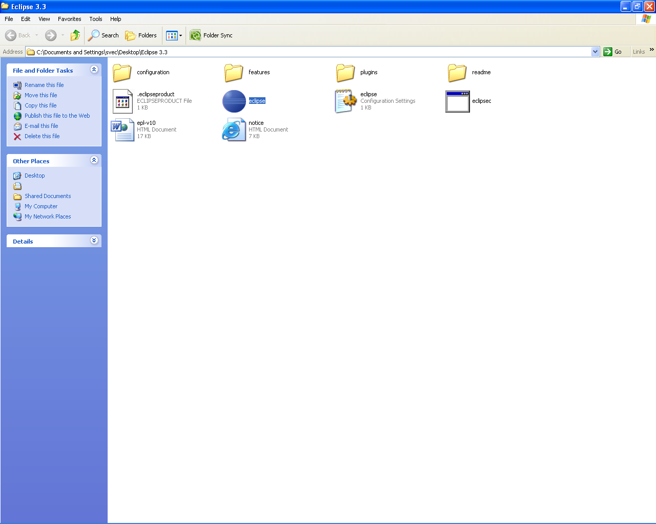

**1.3 Create a workspace for Eclipse**

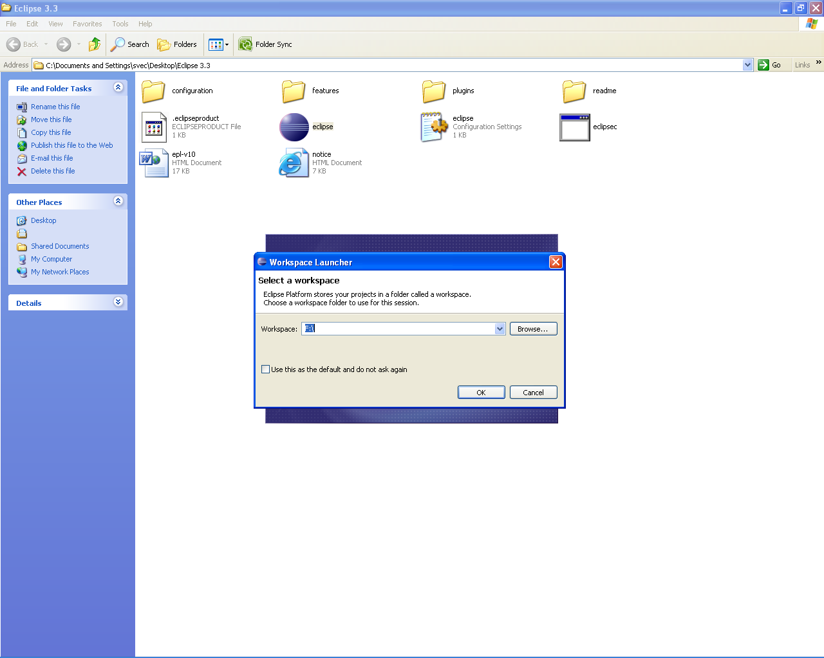

**1.4 Eclipse will be loaded**

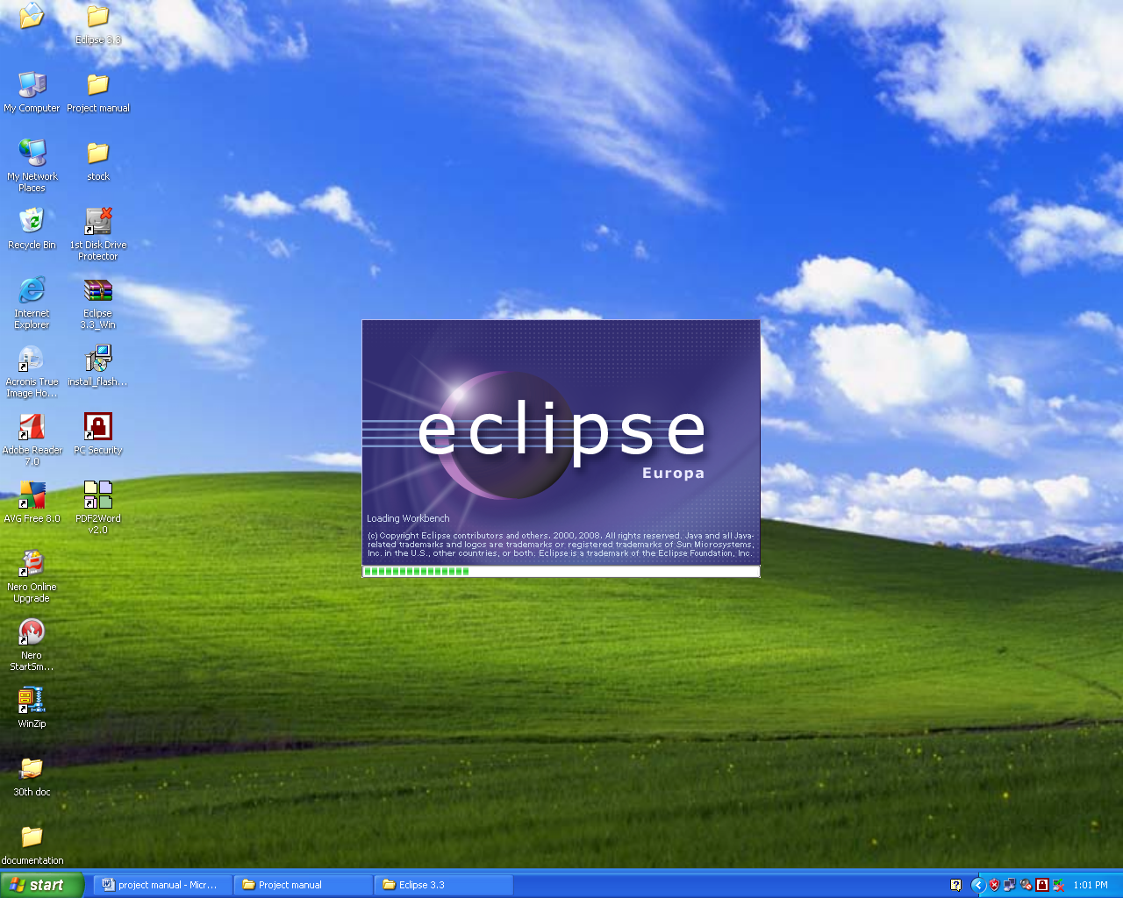

**1.5 Selecting the j2ee perspective**

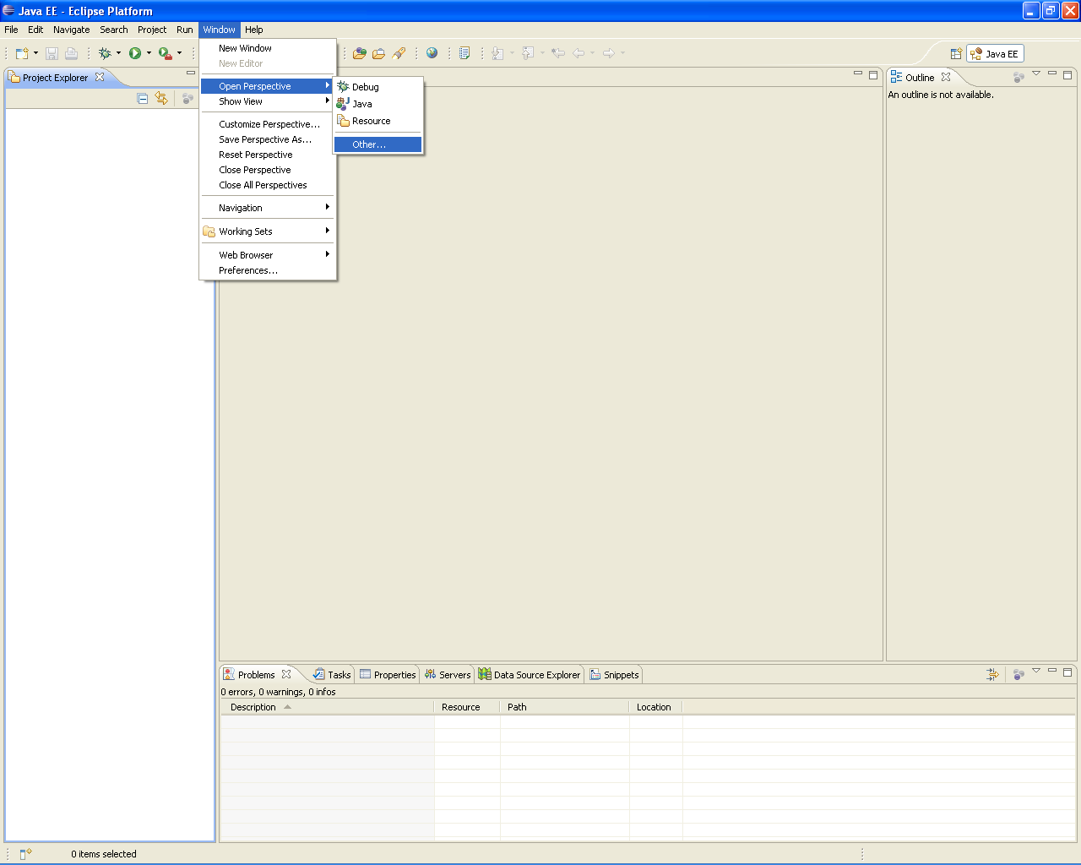

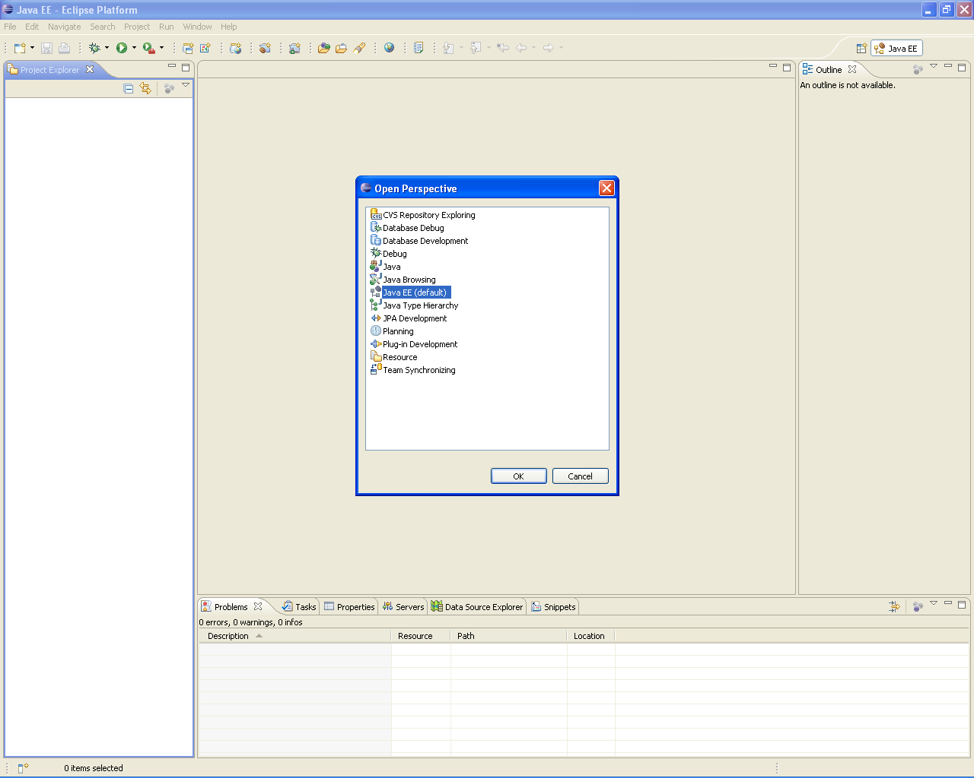

* 1. **Creating a new Project**

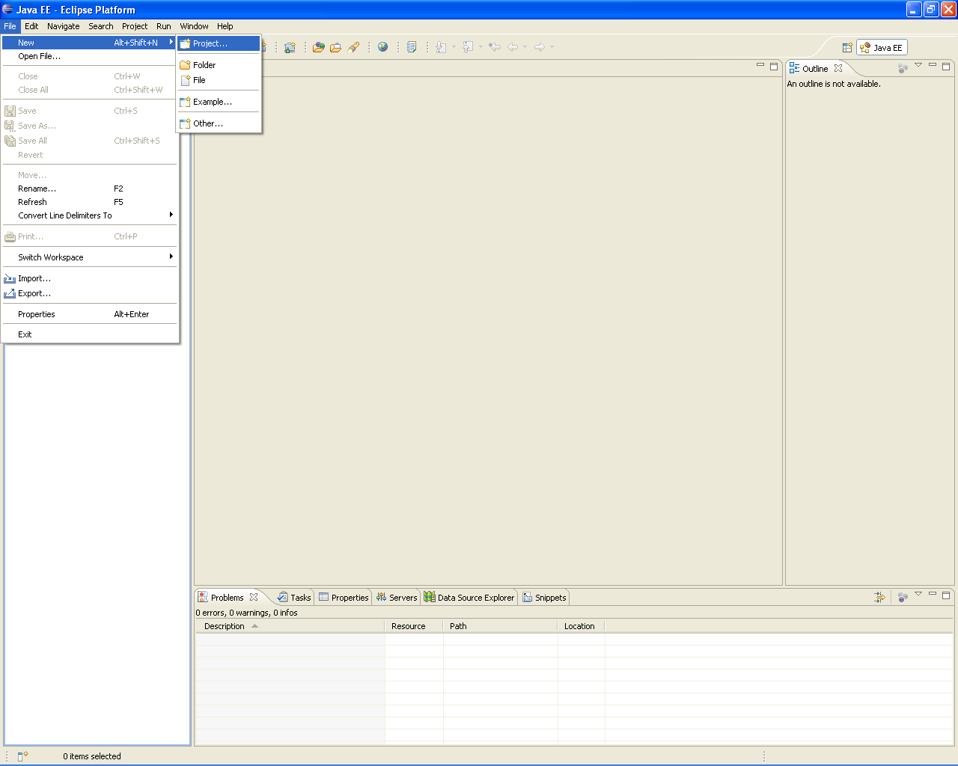

**1.7 Selecting the type of project as Dynamic Web Project**

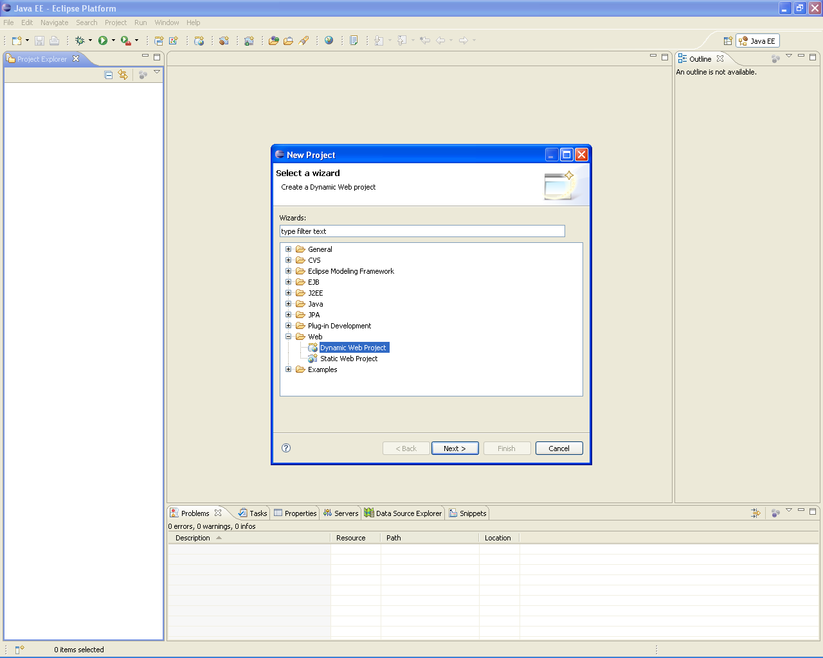

**1.8 Naming the Project**

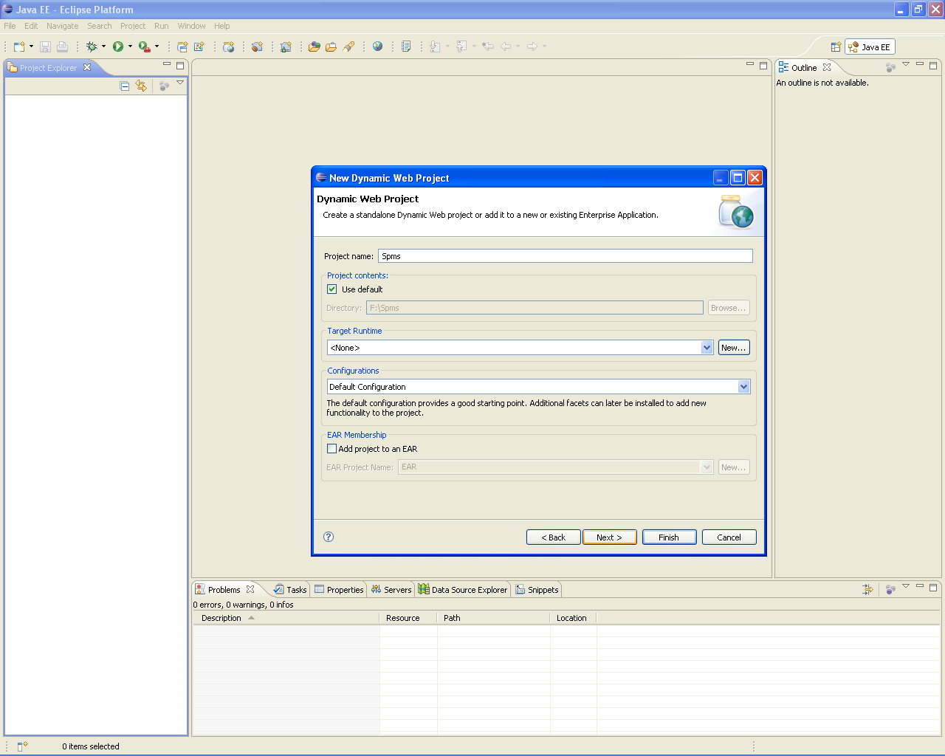

**1.9 Select the Geronimo Deployment Facets that are requires for the project**

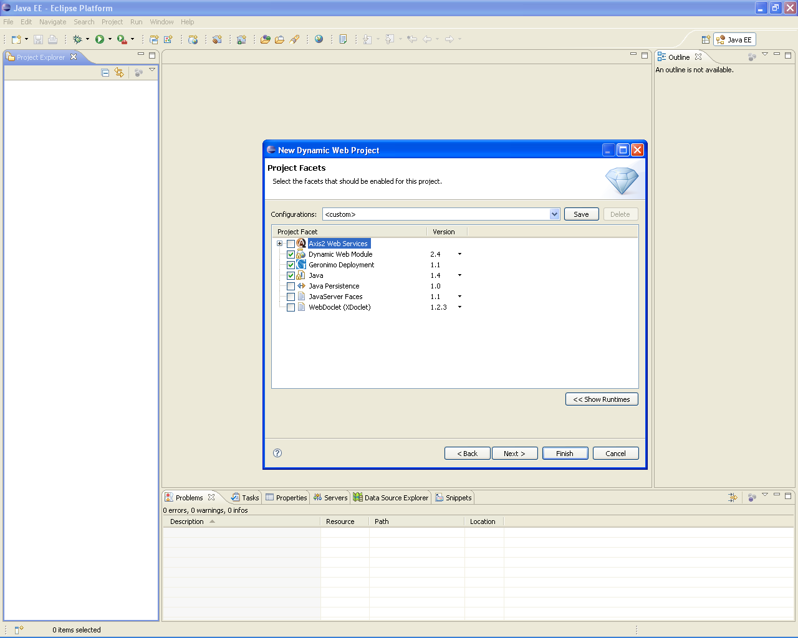

**1.10 Configure the module settings toContent root:Spms**

**Content directory:Web Content**

**Java Source Directory:src**

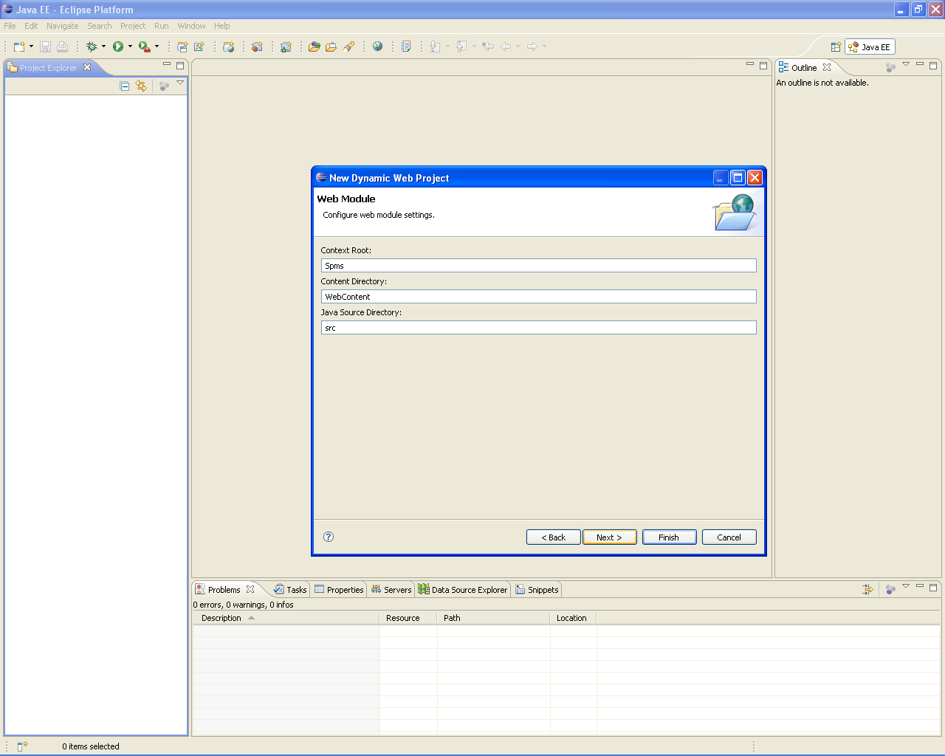

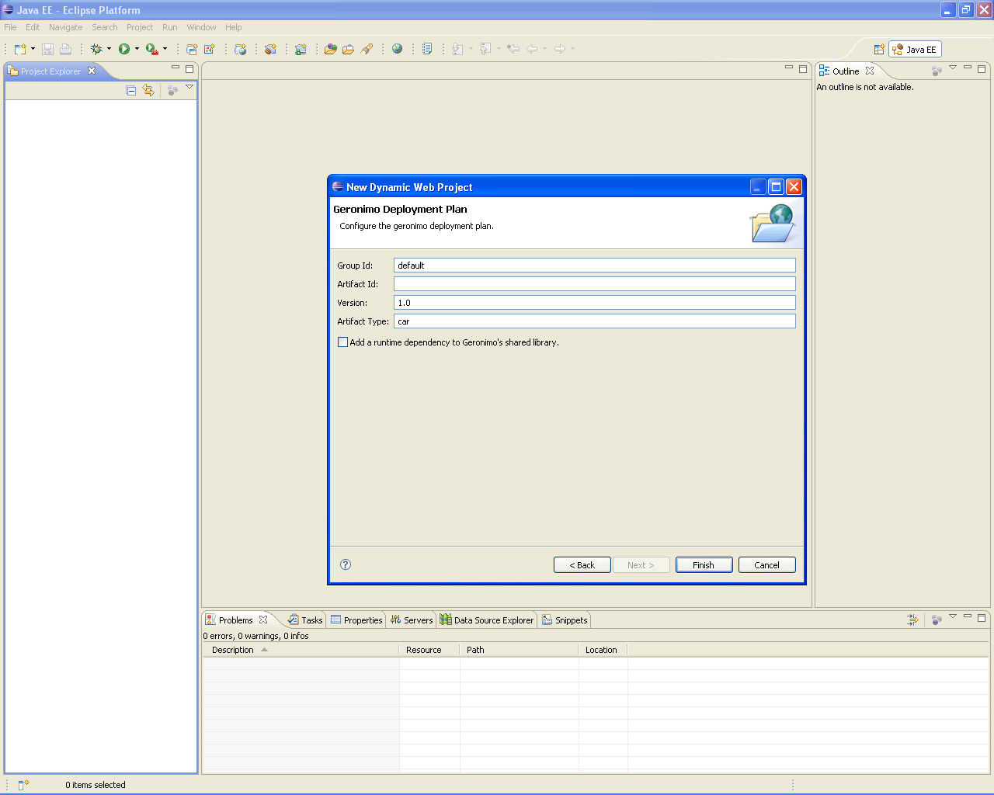

**1.11 Configuring the build path for adding Servlet Jar Files**

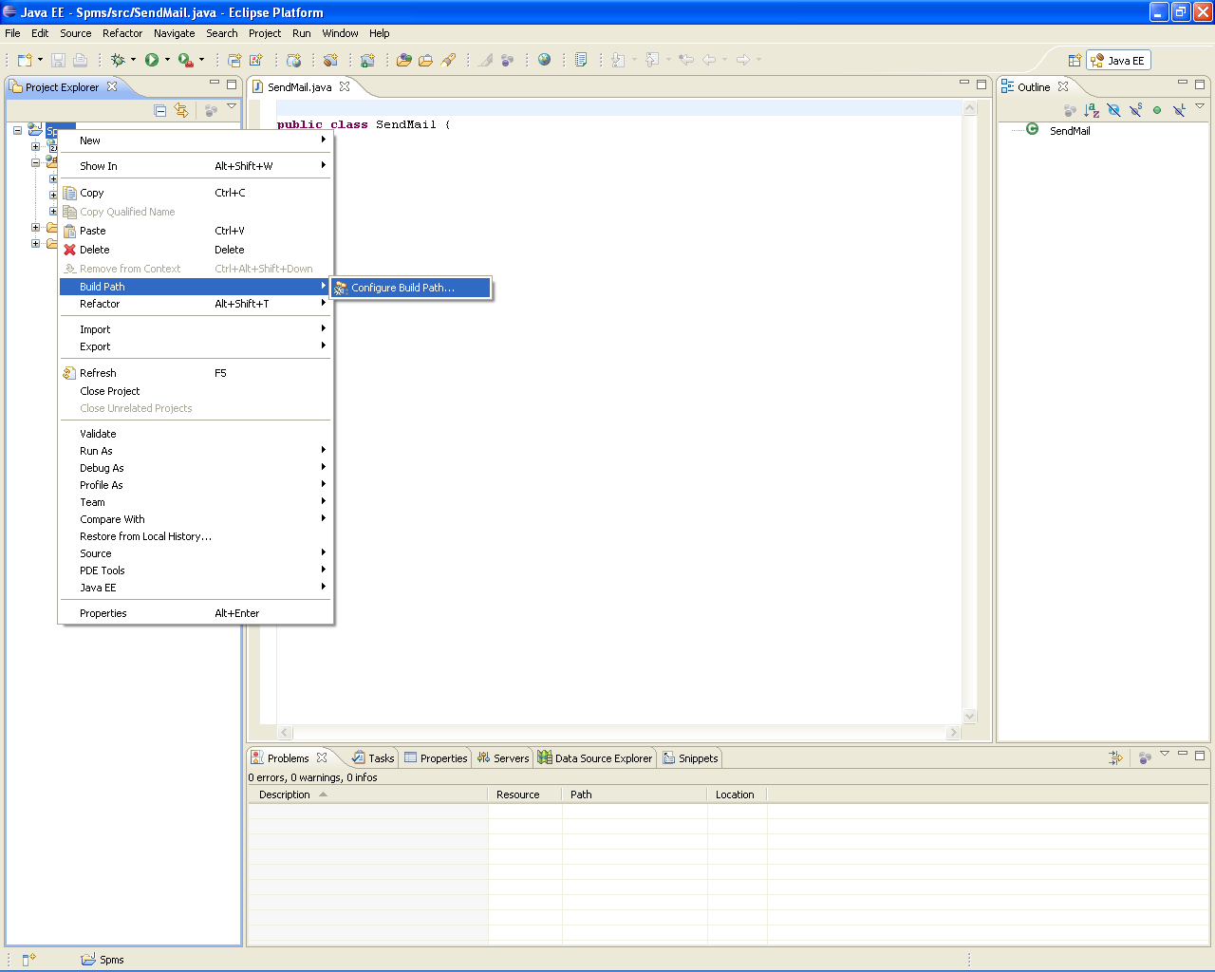

**1.12 create Build Path while creating servlet**

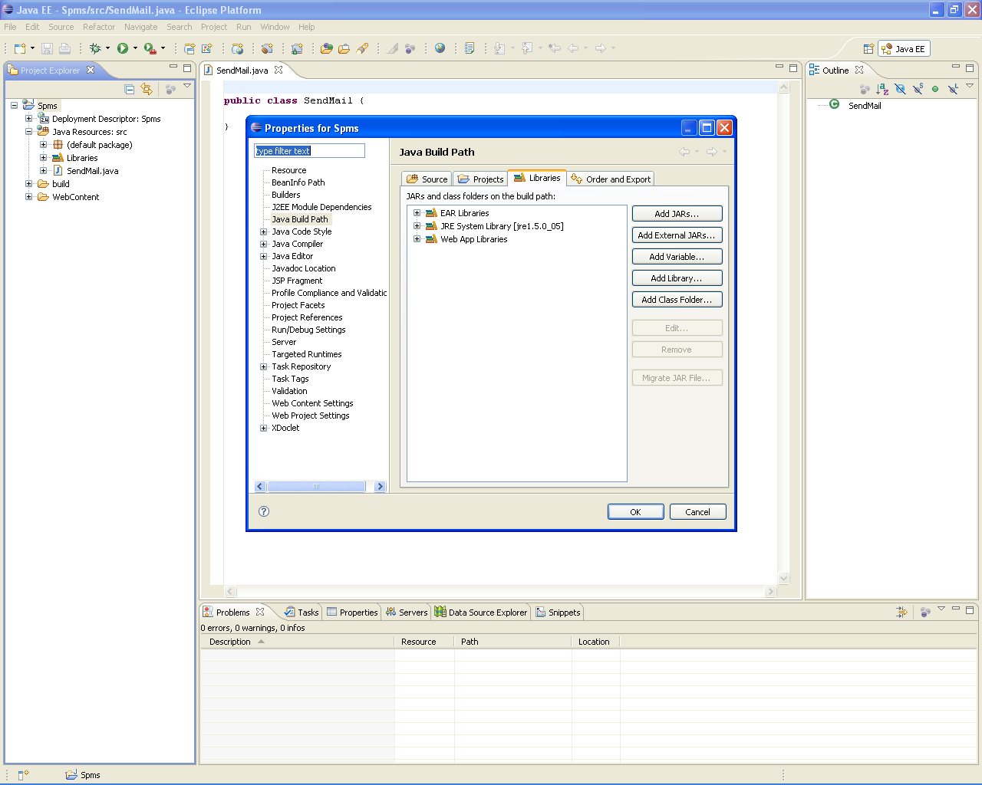

**1.13 Searching the eclipse plugin path by Browsing**

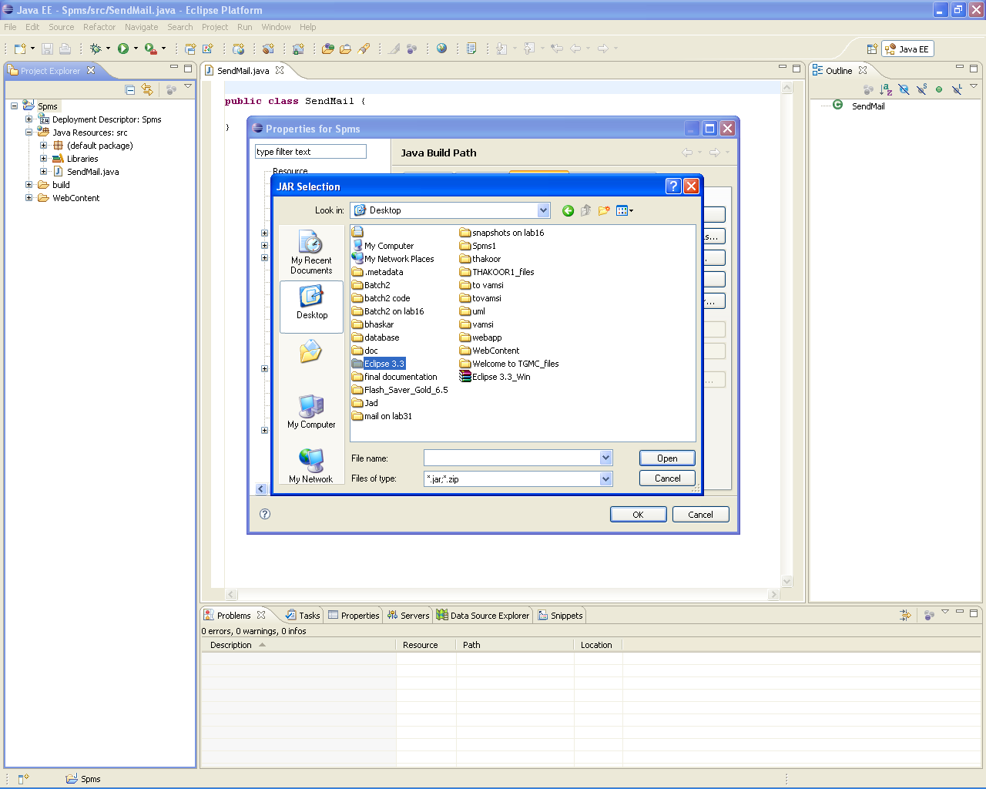

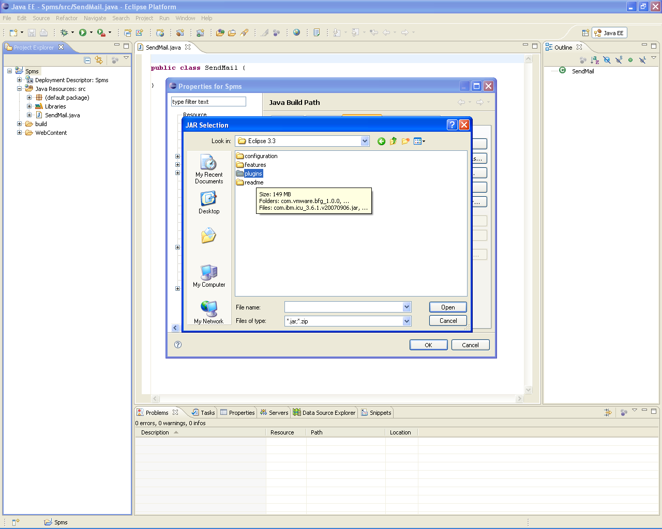

**1.14 Selecting the servlet packages**

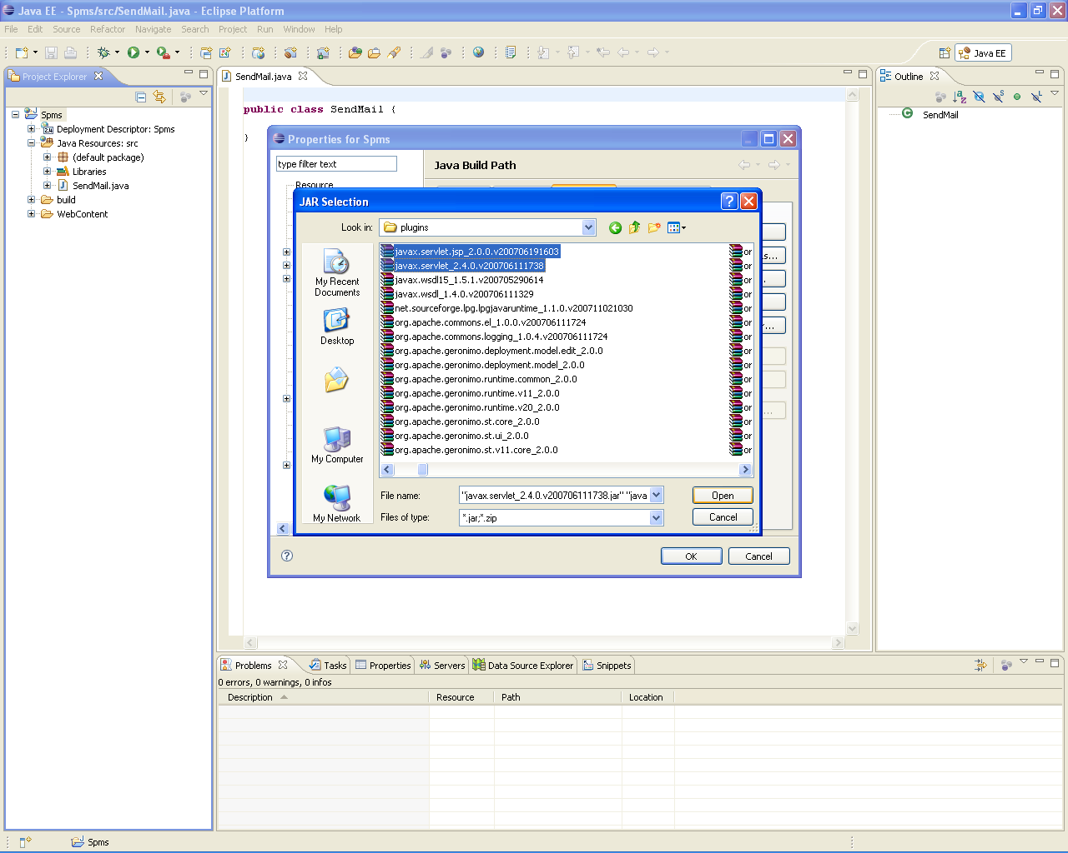

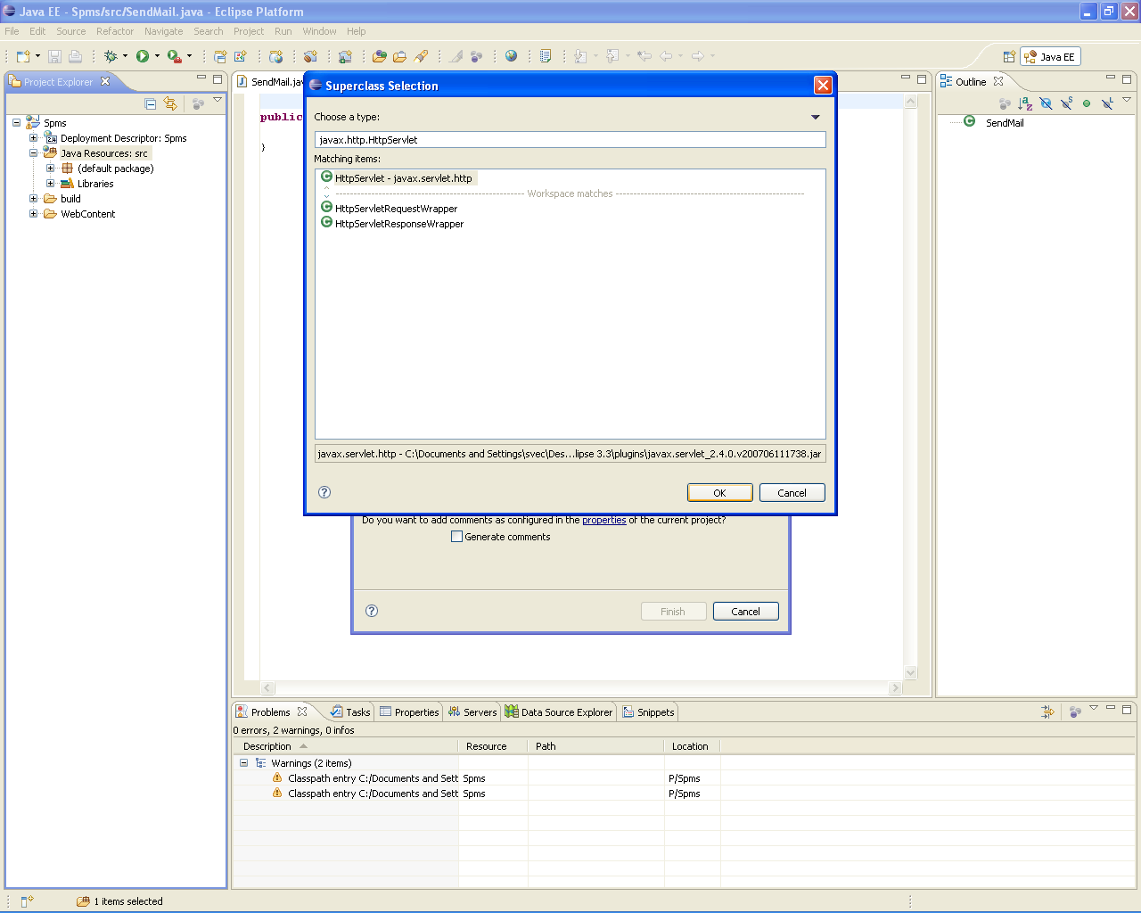

**1.15 Import Database Supporting external Jar file**

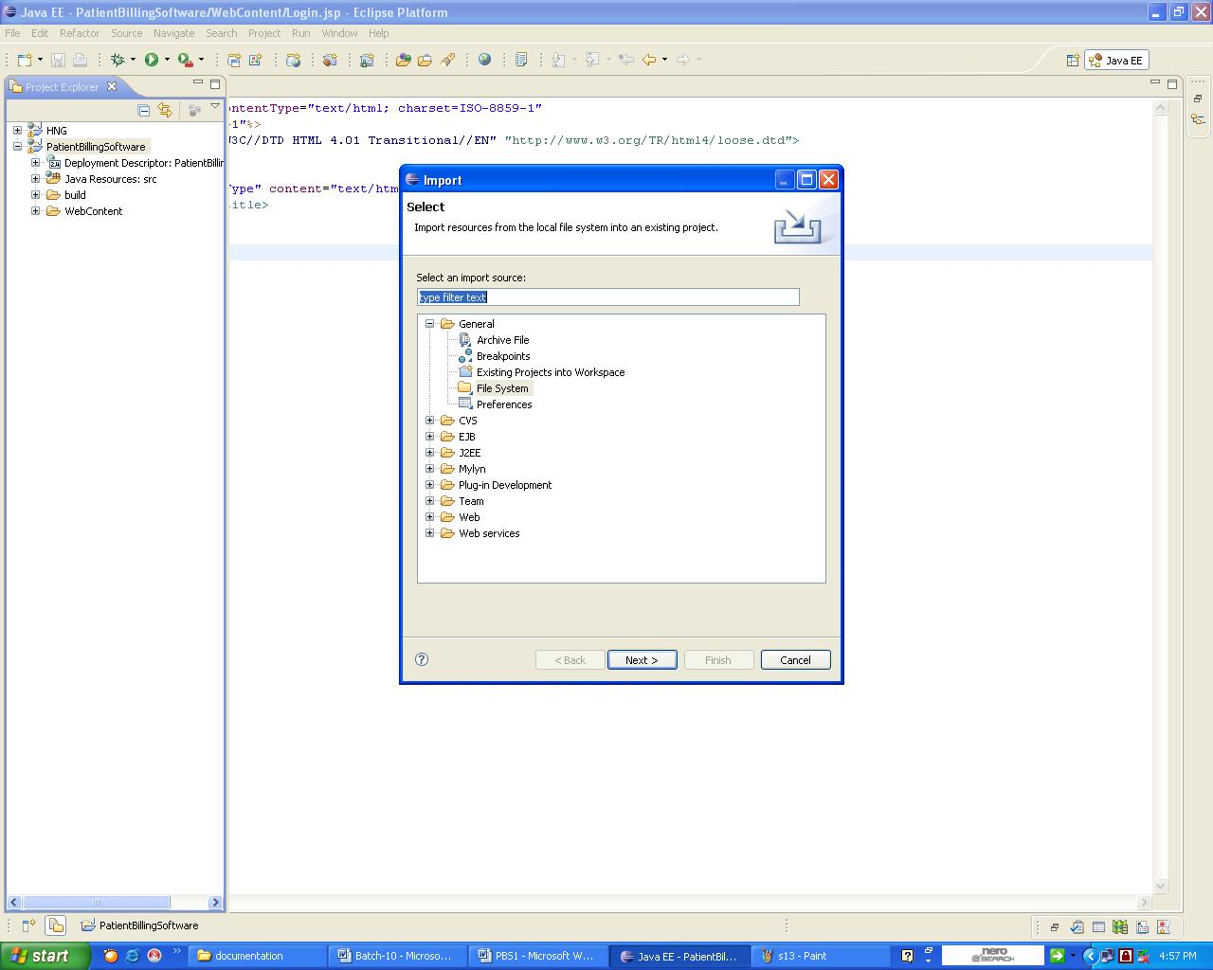

**1.16 select external file system**

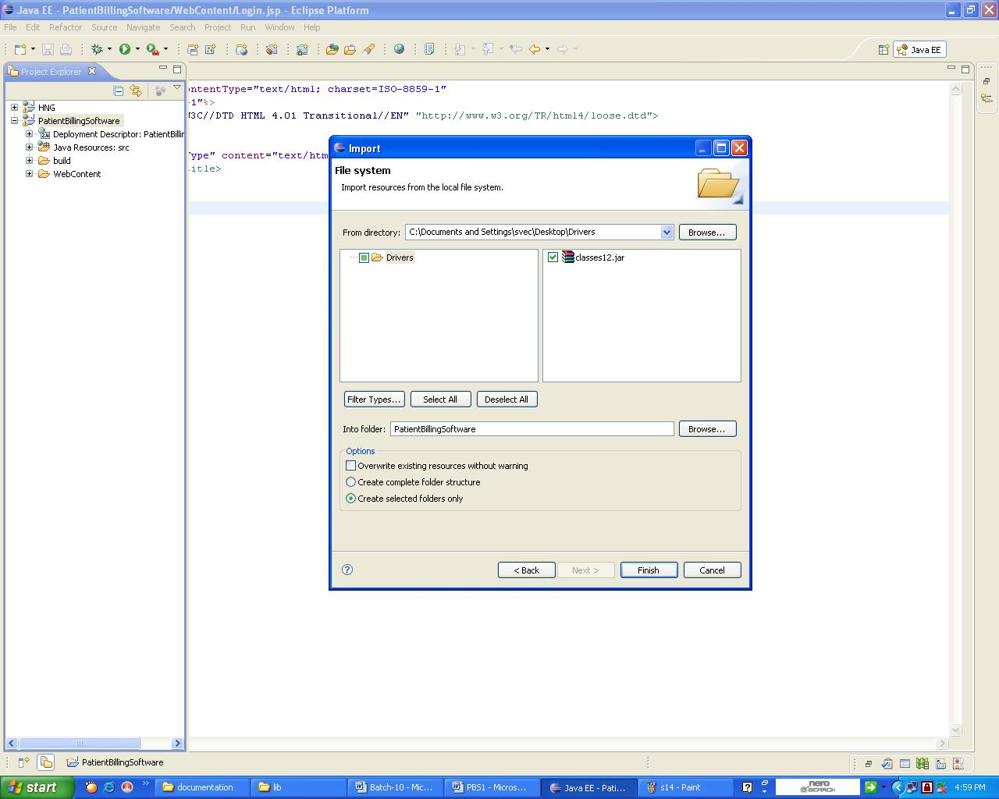

**1. 17 Creating a new class**

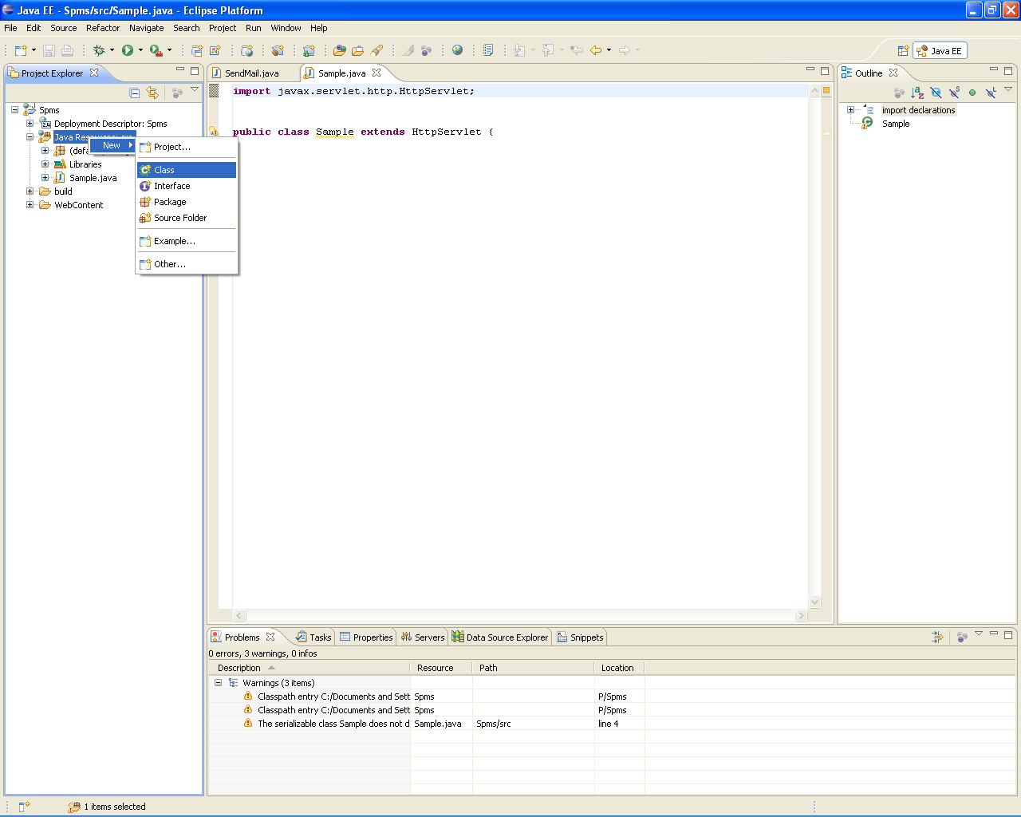

**Select Package,methods,constructors.**

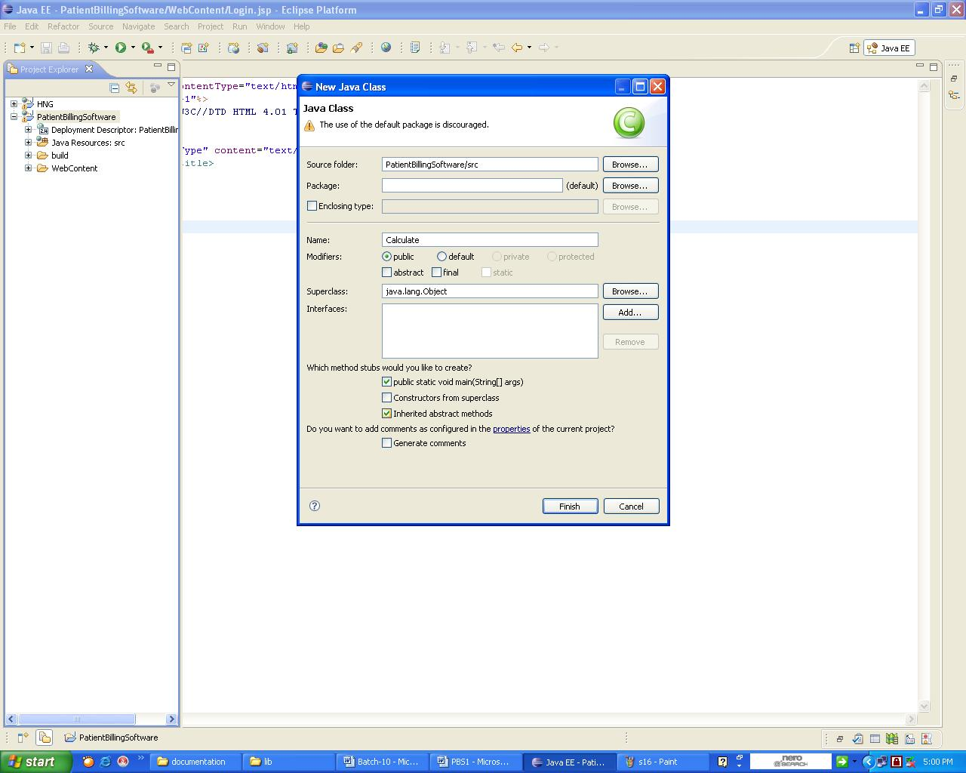

**1. 18 Creating a Html page.**

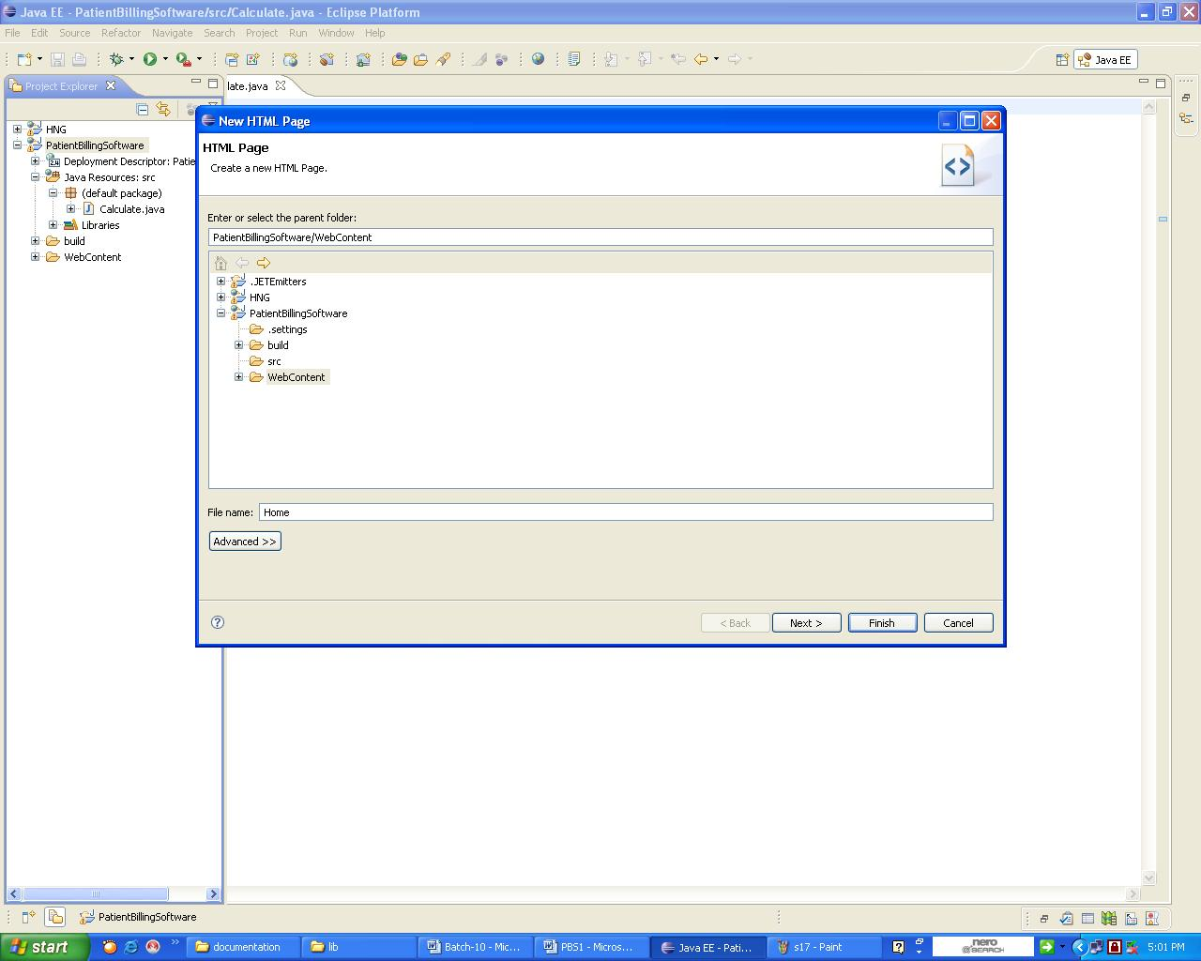

**1.19 Creating a new jsp**

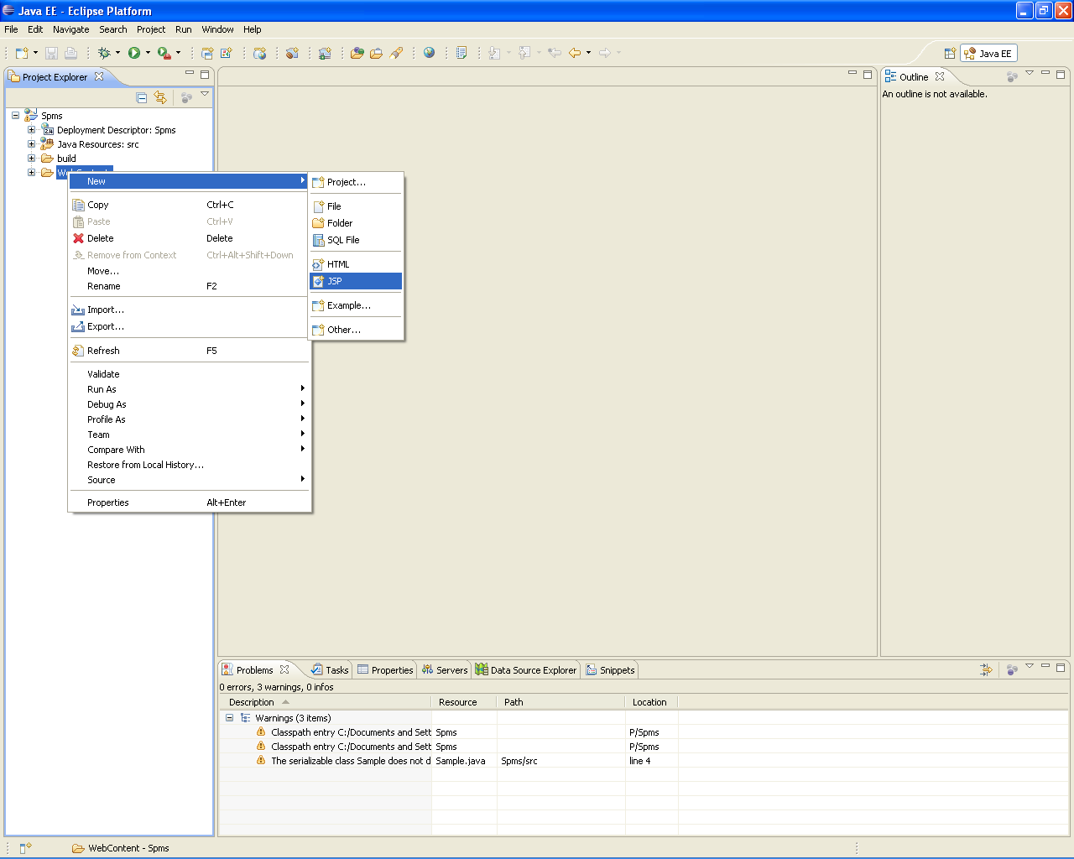

**1.20 Naming the Jsp**

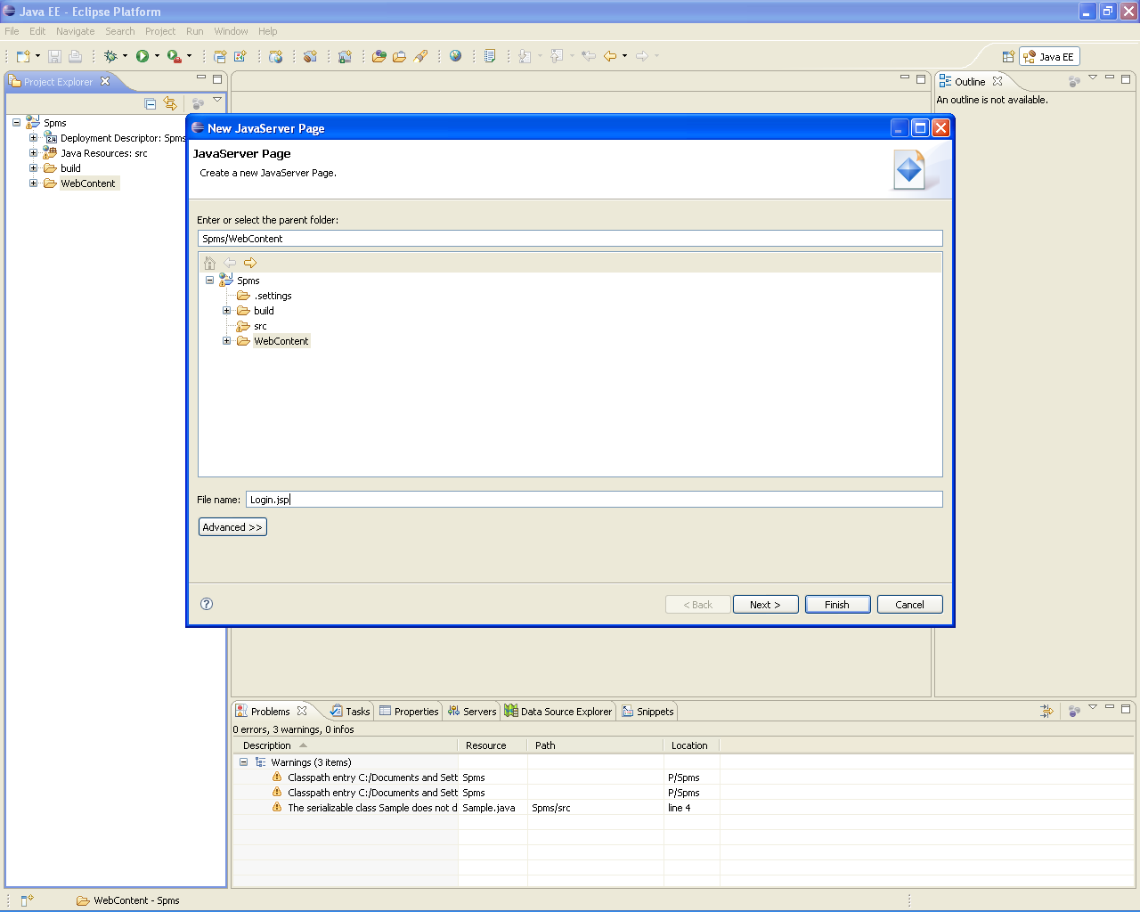

**1.21 Exporting the WAR file**

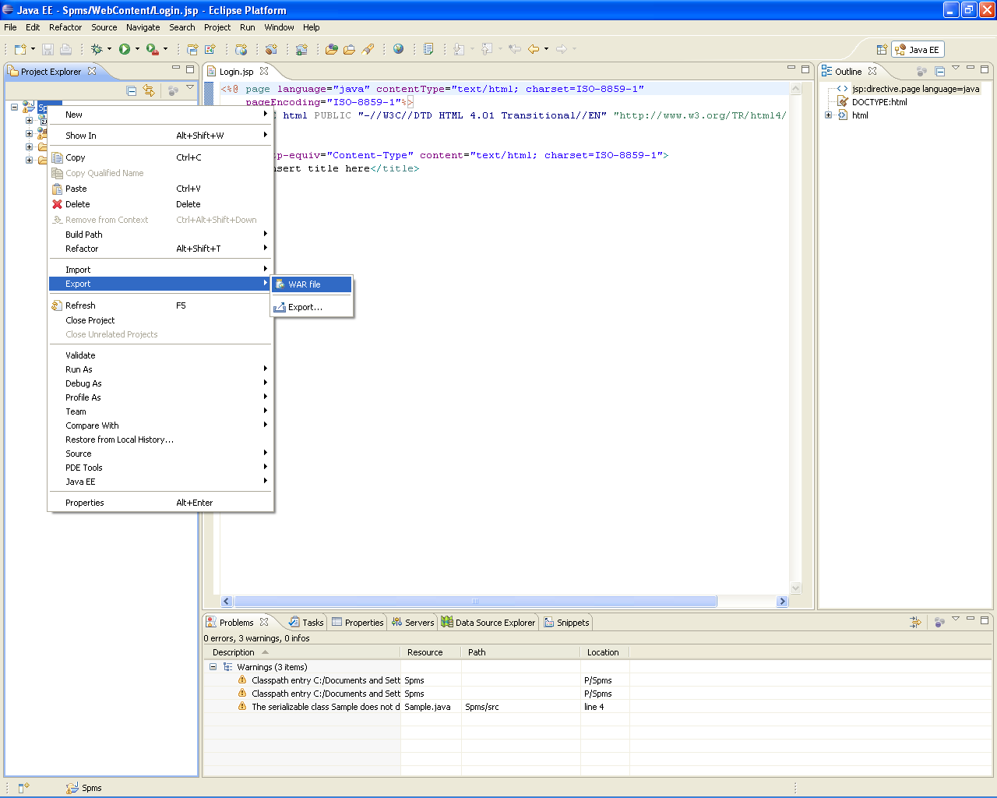

**1.22 Path for the WAR file**

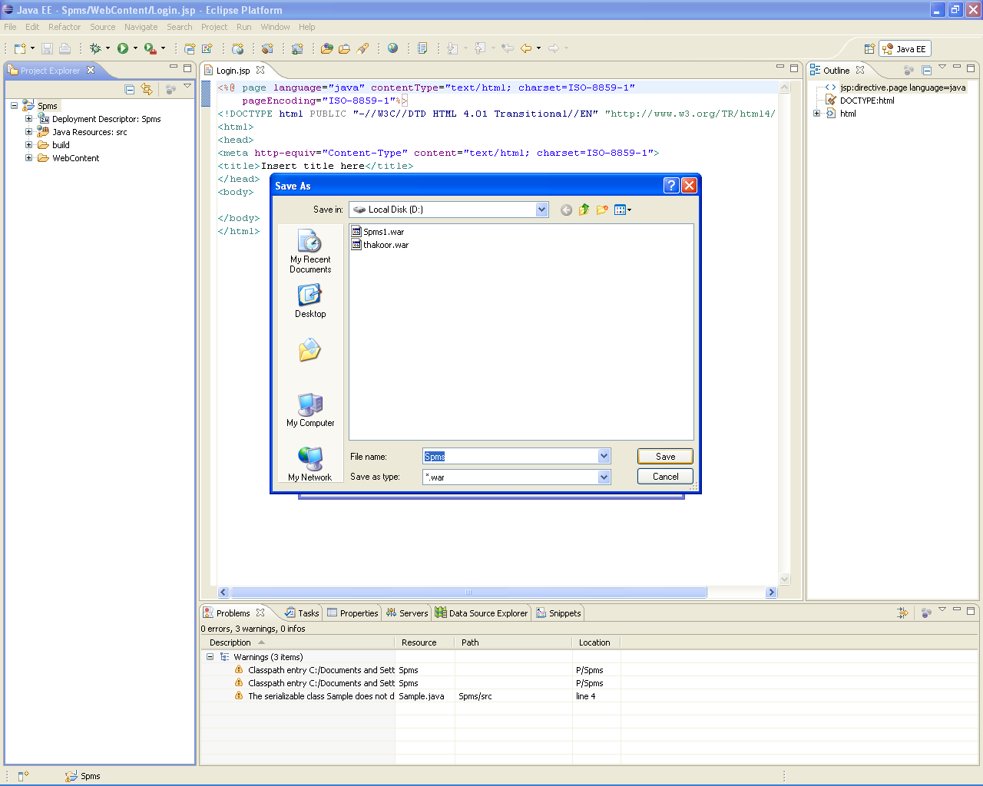

**1.23 Exporting to the location Selected**

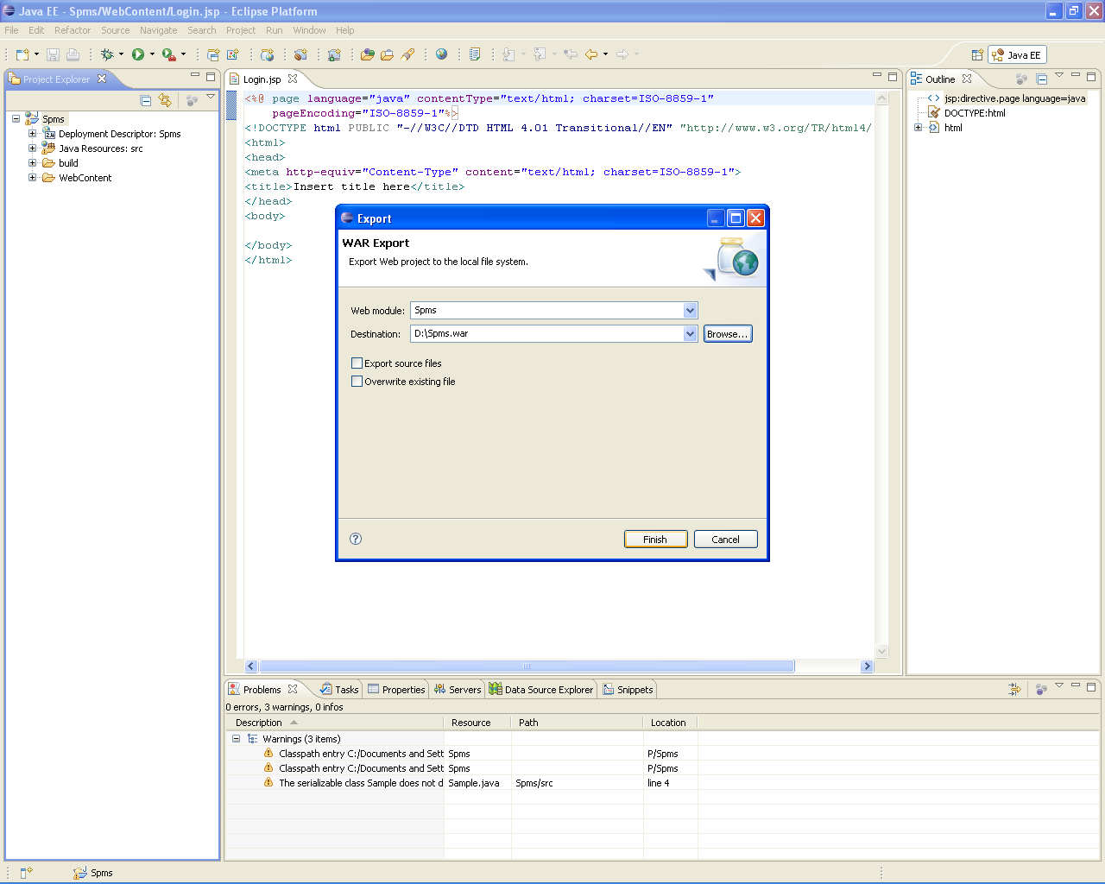

LIST OF JSP,SERVLETS,HTML

|  |  |  |
| --- | --- | --- |
|  | **List Of Servlets** | **List Of HTMLS** |
| 1. **Registration** 2. **Admin** 3. **alertslink** 4. **ATMlocations** 5. **Banklocations** 6. **Bloodbanks** 7. **BP_Home** 8. **Busea** 9. **profile** 10. **Cardealers** 11. **Cityview** 12. **City_info** 13. **Education** 14. **flighttimings** 15. **ftimings** 16. **Functionhalls** 17. **Gasdealers** 18. **Gmap** 19. **Healthline** 20. **Hydphotogallery** 21. **Insertalert** 22. **Insertresume** 23. **Admin_home** 24. **image** 25. **Indu1** 26. **JS_home** 27. **LoginPage** 28. **ViewProfile** 29. **Open_Home** 30. **Resume** 31. **Retrieve** 32. **show** 33. **Loginpage** 34. **ViewTh** 35. **Update** 36. **Update1** 37. **Photoframe** 38. **Tourist_Home** 39. **ViewIndus** 40. **Viewdetails** | 1. **alerts** 2. **bussearch** 3. **validation** 4. **Hotel** 5. **Image** | 1. **index** 2. **error1** 3. **error2** 4. **Home** 5. **Homepage** 6. **Login** 7. **Alerts** |

**2. Steps to Importing created War File into another system**

**2.1 Copy the SPMS WAR file provided in the deliverables folderto your machine.**

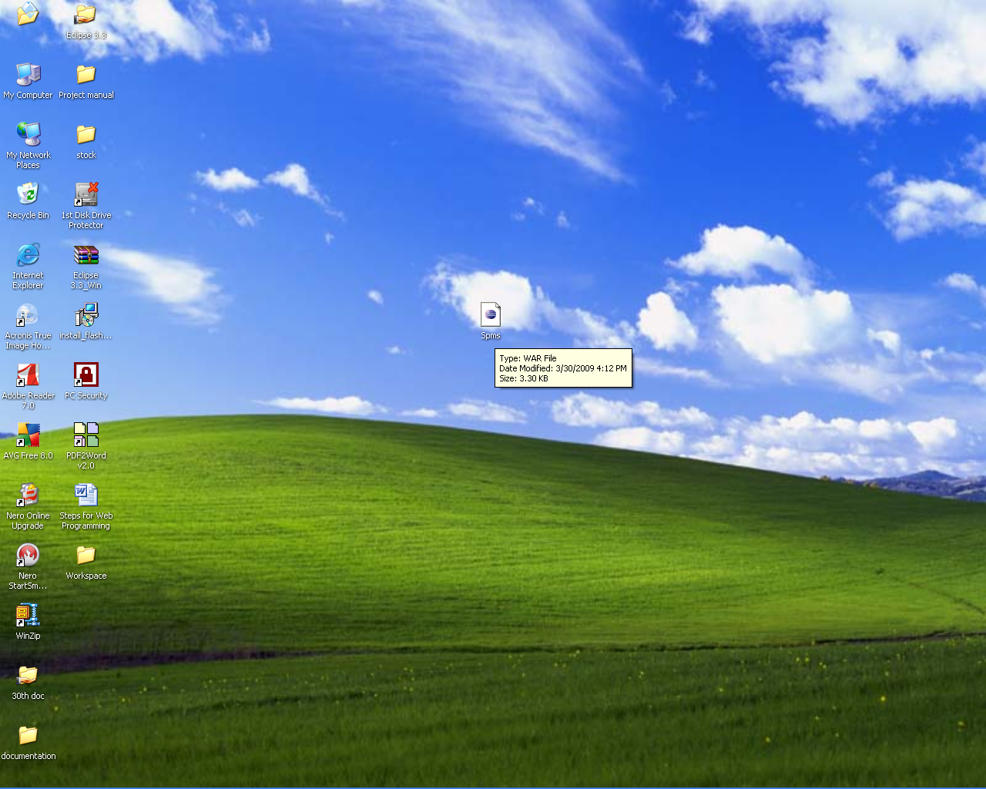

**2.2 Open the workspace in your system using eclipse.**



**2.3 Click on File -Open file**

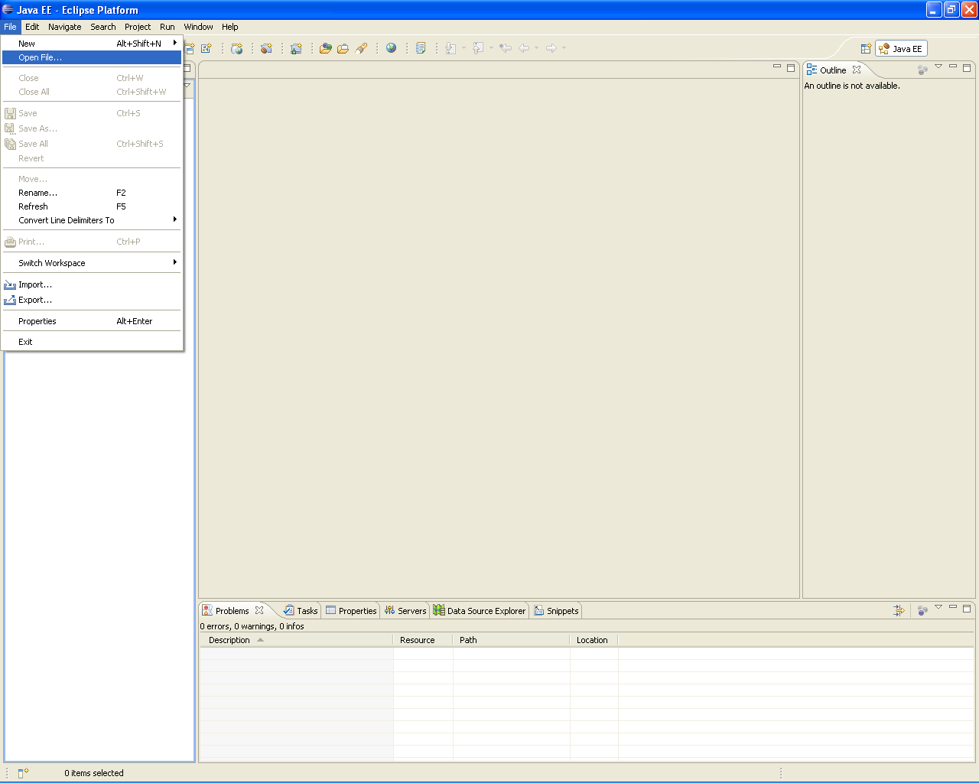

**2.4 Select the WAR file to open**

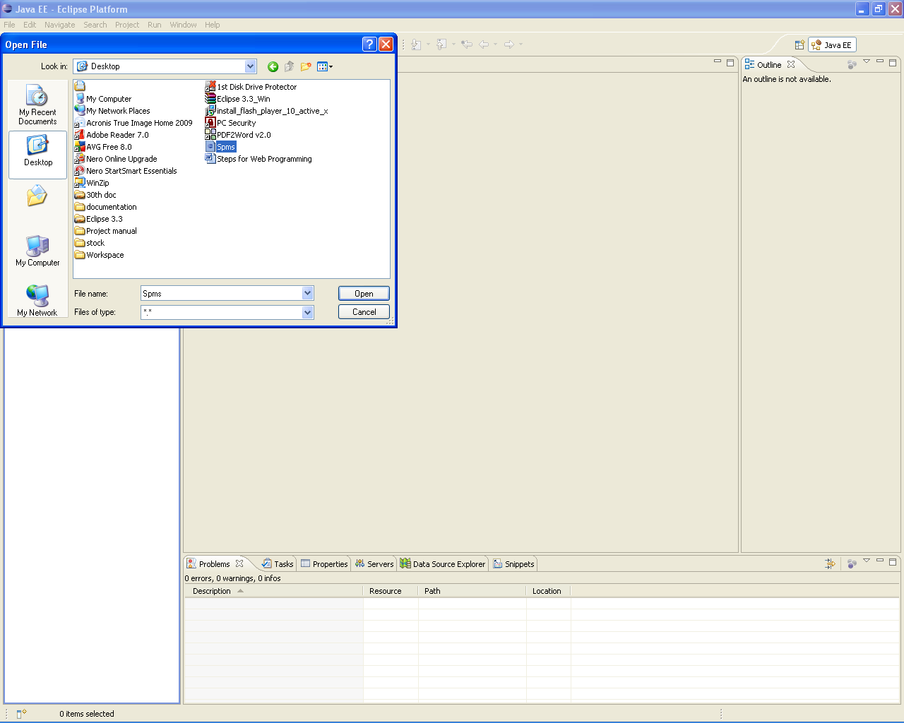

**2.5 Project will be opened (make sure that your workspace is not already in use)**

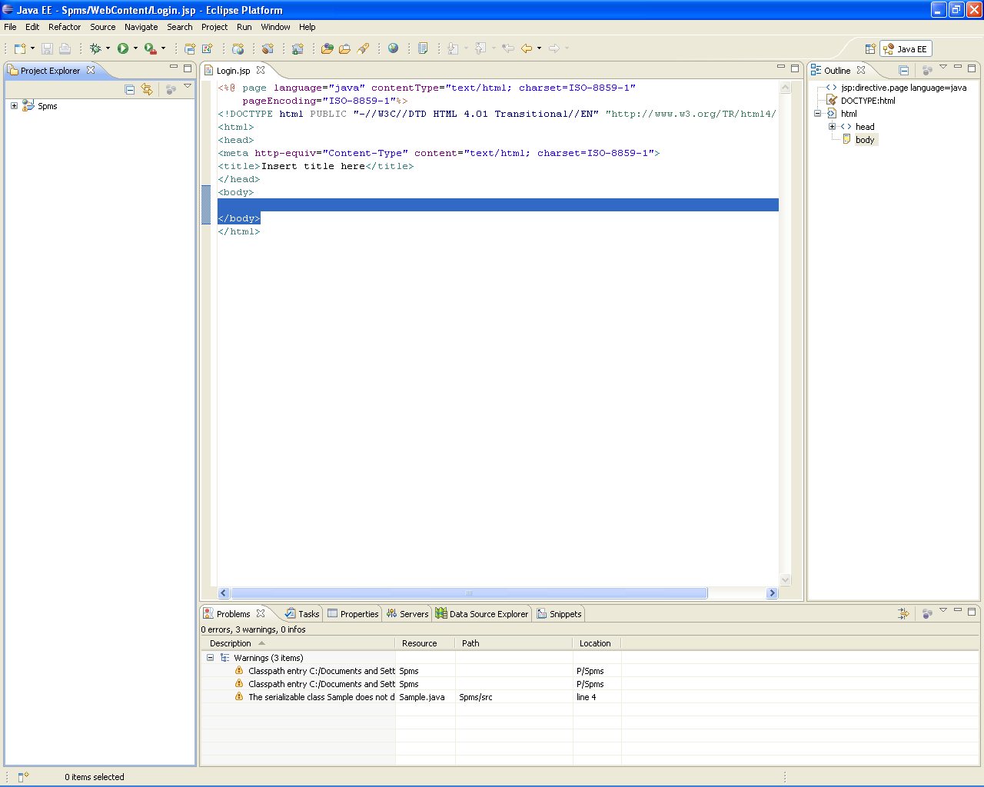

**2.6 Configuring the build path for adding Servlet Jar Files**



**2.7 Create Build Path while creating servlet**



**2. 8 Searching the eclipse plugin path by Browsing**





**2. 9Selecting the servlet packages**



**2.10 Import Database Supporting external Jar file**



**2.11 Select external file system**



**2.12 Exporting the WAR file**



**2.13 Path for the WAR file**



**3. Steps to Deploy the War file in IBM Application Server**

**URL :** [**http://Ipaddres:port/console**](http://Ipaddres:port/console)

**Ex:** [**http://172.16.41:8080/console**](http://172.16.41:8080/console) **as shown in below screenshot**

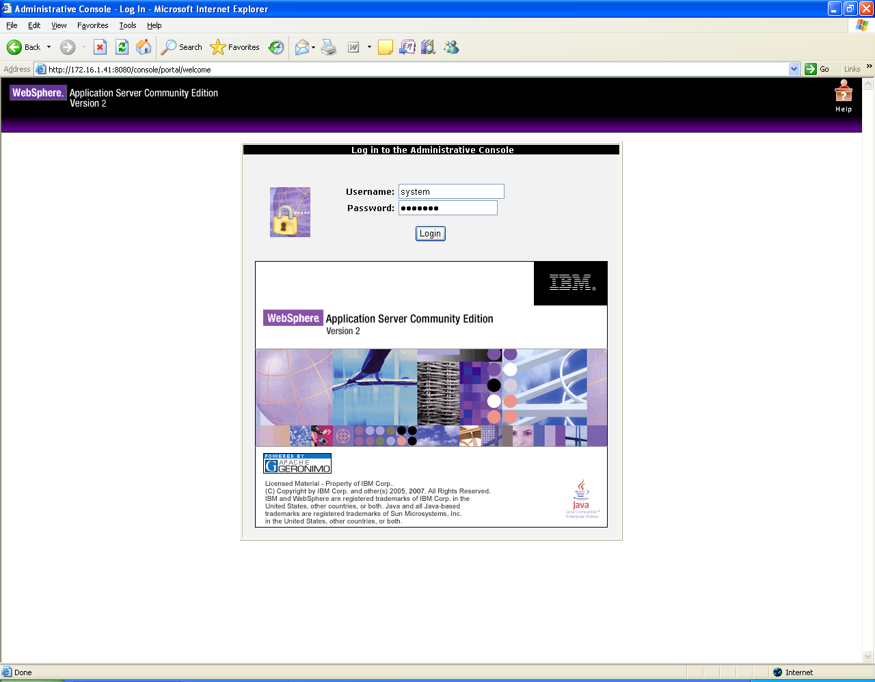

**3.1 Enter User Name (system), Password (manager) and Click on Login button as shown above.**

**3.2 The following screen should be displayed after successful Login.**

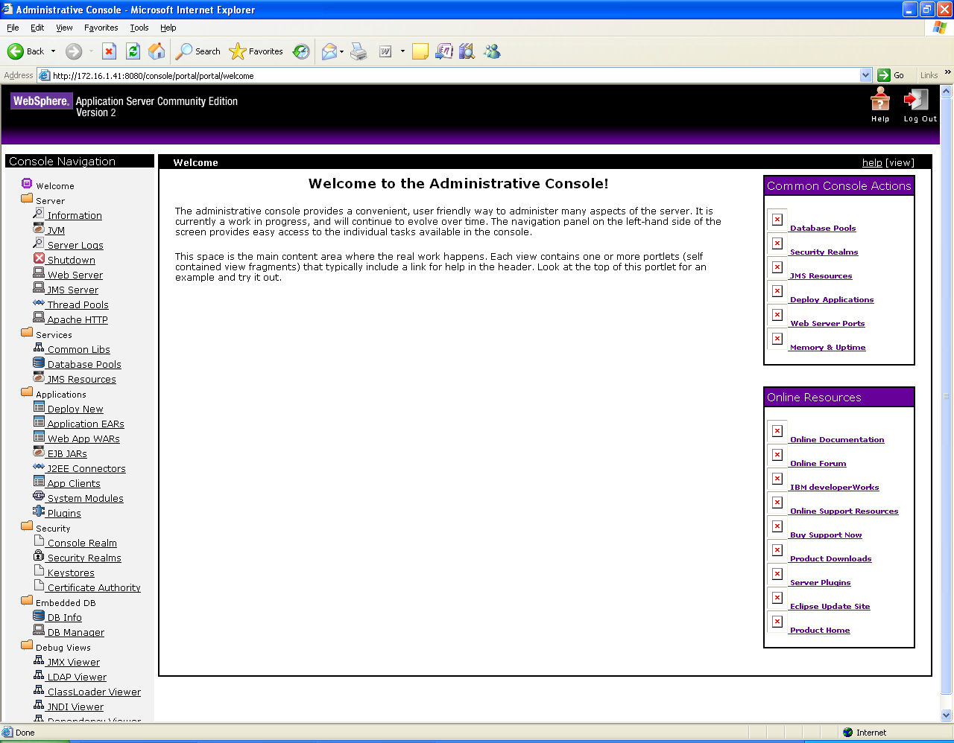

**3.3 Click on “Deploy New” link under Applications Section of Home page. The following screen is displayed having Archive and Plan**

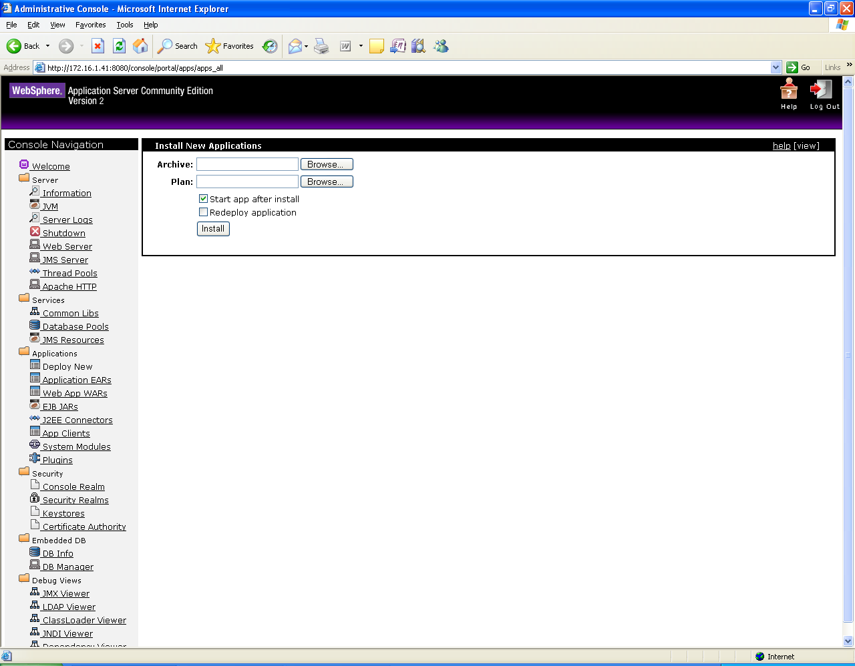

**3.4 Click on Browse button and select the “WAR file” and click on Open button**

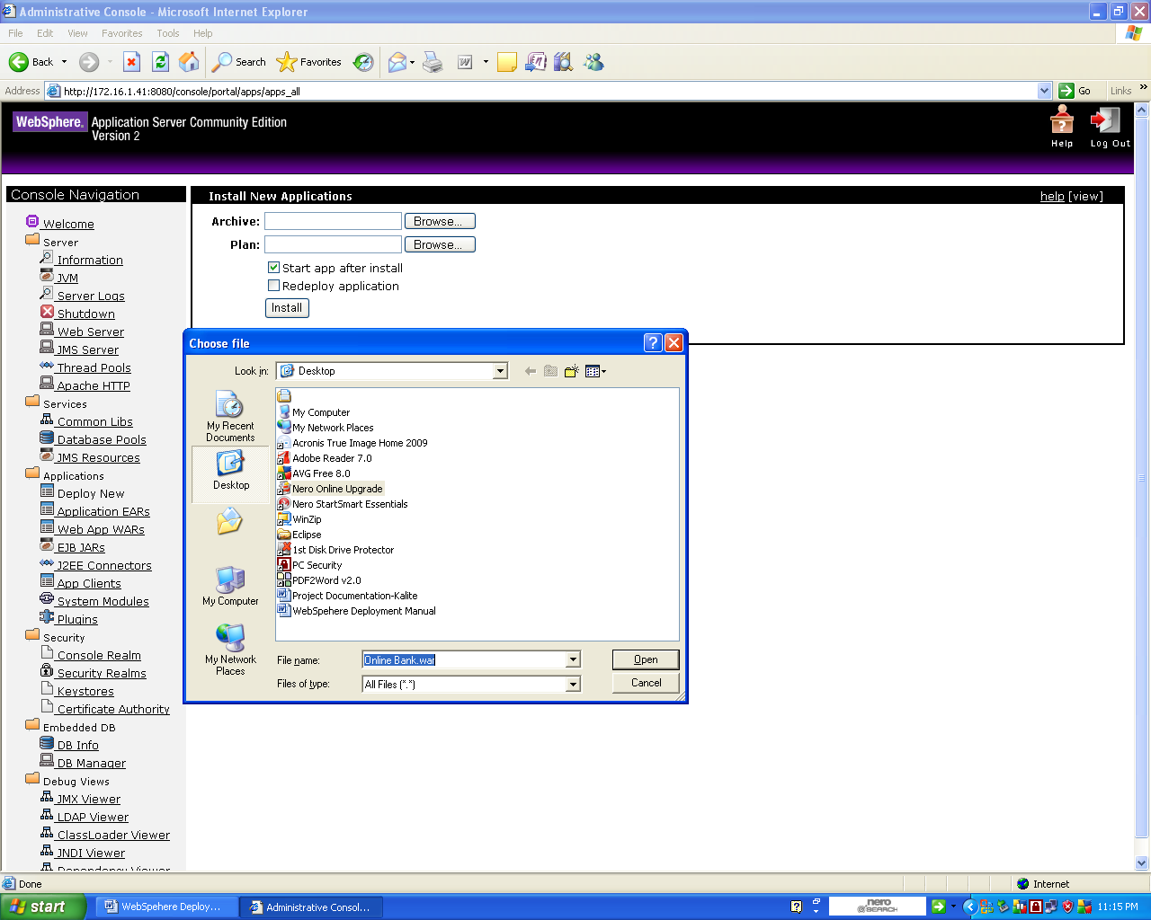

**3.5 Check “Start app after install” after selecting the required War file and Click on Install Button. The following screen should be displayed stating “ The application was successfully redeployed”**

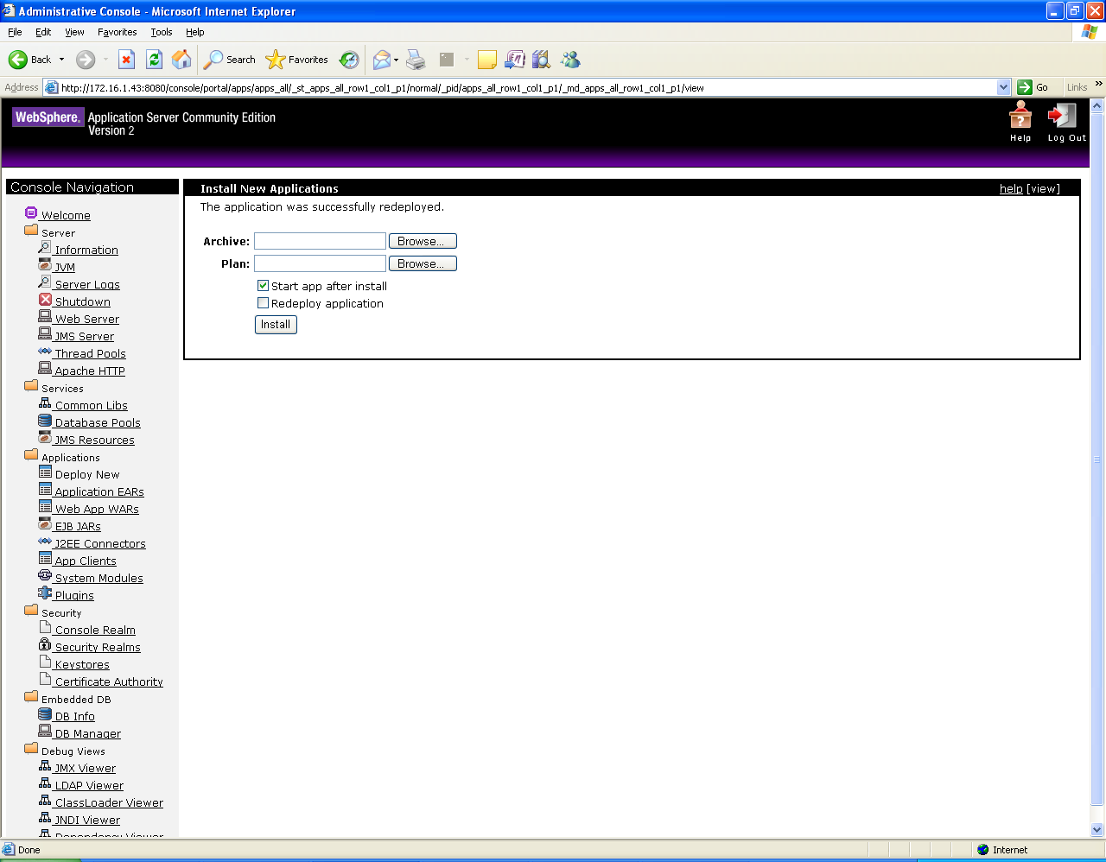

**3.6 Click on “Web App Wars” link under “Applications section”. The following screen is displayed showing all the deployed Wars.**

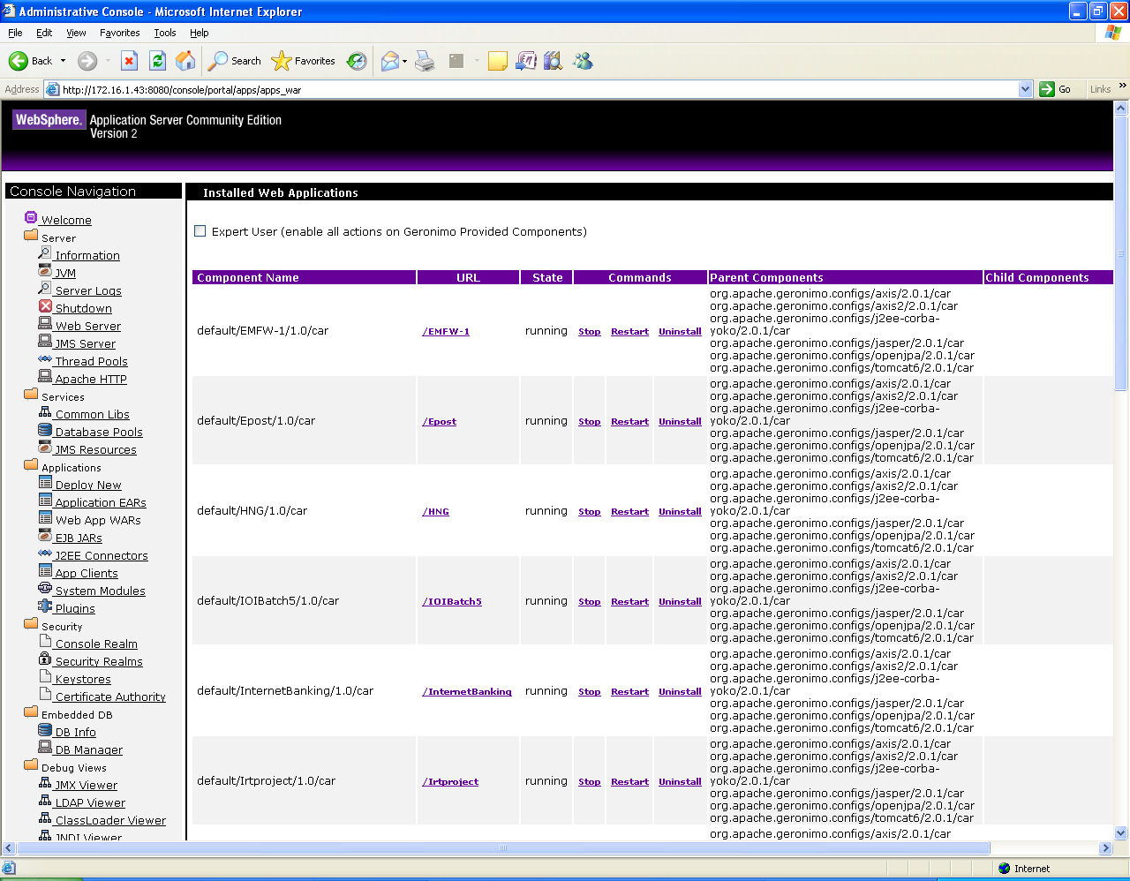

**3.7 Click on “Project_Name.war“ file which is deployed to display the home page of the Application as shown below.**

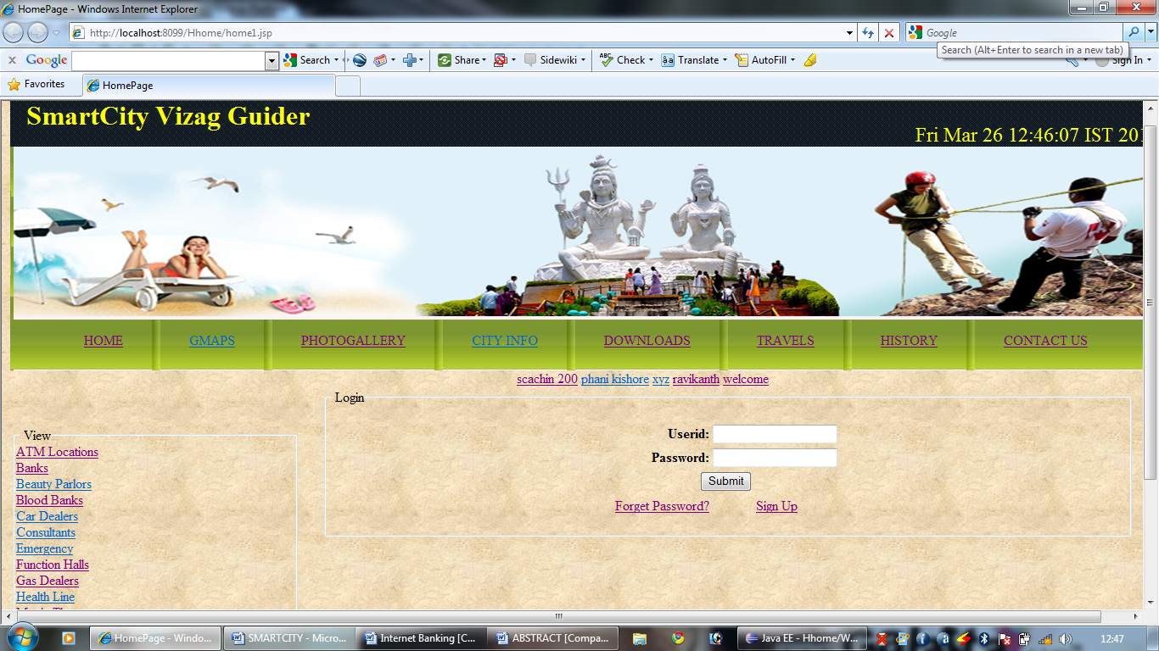

**4. Steps to Installation of Database Server**

**Installation Instructions:**

**• Follow every step in this guide unless it is marked optional.**

**• Do not change or deviate from any step unless told to do so by your**

**instructor or Heinz Computing staff member.**

**• Only start this installation when you can dedicate 3-4 hours of your time**

**• Report any installation errors/problems to**

**heinz-computing@andrew.cmu.edu.**

**Please include in your email:**

**o The step you were on when the error occurred**

**o A screen shot (Print Screen button) of the error**

**o The error number and exact text of the error**

**Step #1: Installing Personal Oracle 10g**

**1-1. Insert the Oracle 10g Database10.1.**

**1-2. Select the Install/Deinstall Products button.**

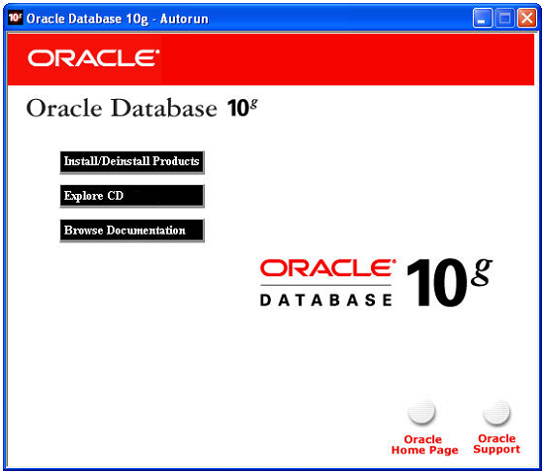

**1-3. The Welcome window opens.**

**1-4. Select Advanced Installation**

**1-5. Click the Next button.**

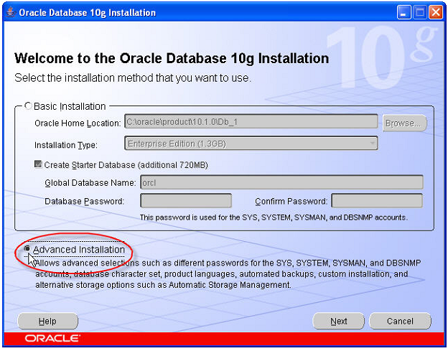

**1-6. The File Locations window opens.**

**1-7. Change the Destination Name to: OraHome10**

**1-8. Change the Destination Path to c:\oracle\product\10.1.0\OraHome10**

**NOTE: Adjust accordingly if you want to install Oracle on a drive other than C:. If you use a**

**different destination path, please write it down. You will need to enter this path later during**

**configuration.**

**1-9. Click the Next button.**

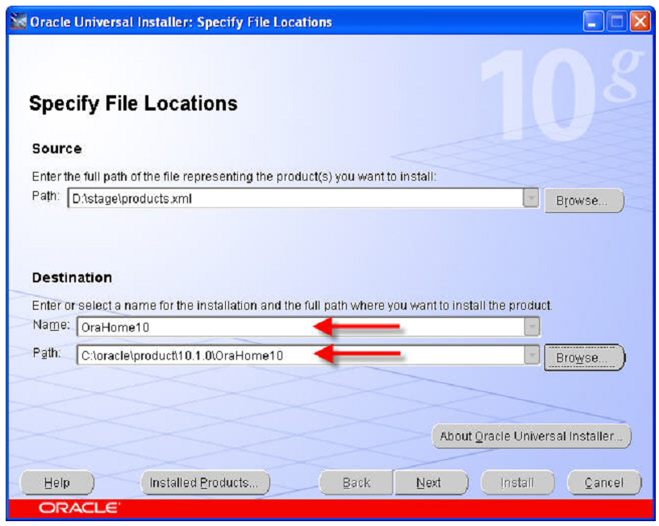

**1-10. The Select Installation Type window opens.**

**1-11. Select Personal Edition (804 MB).**

**1-12. Click the Next button.**

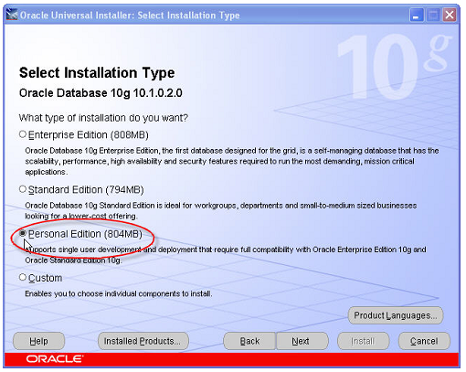

**1-13. You may see the following error message several times during your installation. Click the**

**Continue button each time you see the message.**

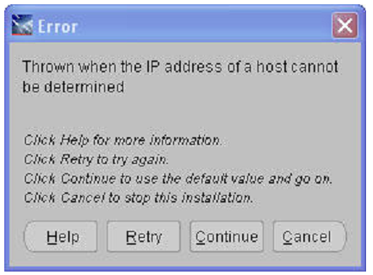

**1-14. The Select Database Configuration window opens.**

**1-15. Select General Purpose.**

**1-16. Click the Next button.**

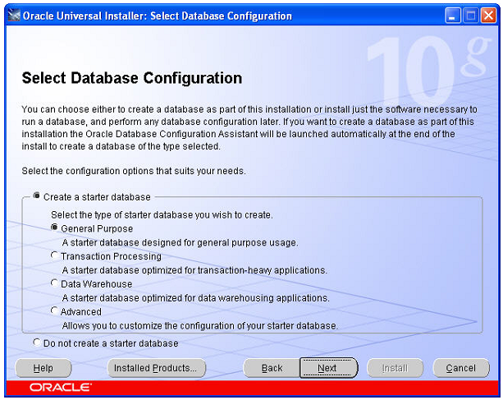

**1-17. The Specify Database Configuration Options window opens. Enter:**

**a. Global Database Name: db1**

**b. SID: db1**

**c. Select Create database with samples schemas**

**1-18. Click the Next button.**

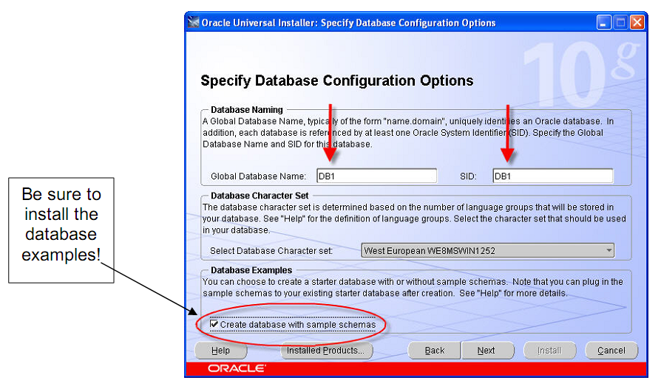

**1-19. The Select Database Management Option window opens.**

**1-20. Click the Next button.**

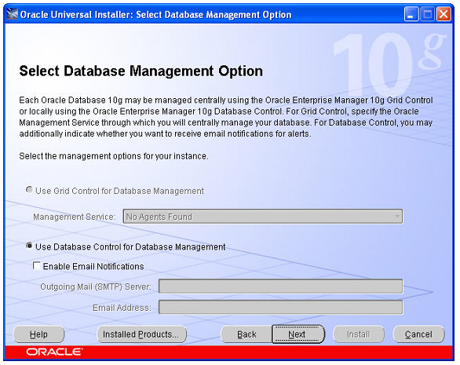

**1-21. The Specify Database File Storage Option window opens.**

**1-22. Keep the default or select a different directory for your database files.**

**1-23. Click the Next button.**

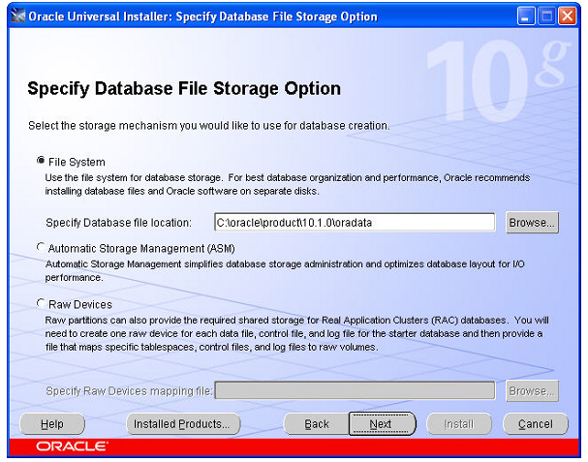

**1-24. The Specify Backup and Recovery Options window opens.**

**1-25. Keep the default settings and click the Next button.**

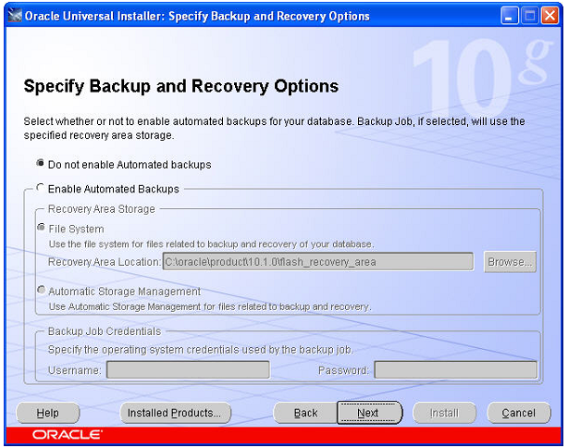

**1-26. The Specify Database Schema Passwords window opens.**

**a. Select Use the same password for all the accounts**

**b. In the Enter Password and Confirm Password fields type johnheinz**

**NOTE: You can choose a different password. Please remember the passwords you entered. You**

**will need to reinstall the Oracle installation if you do not know the passwords for the SYS or**

**SYSTEM accounts.**

**1-27. Click the Next button.**

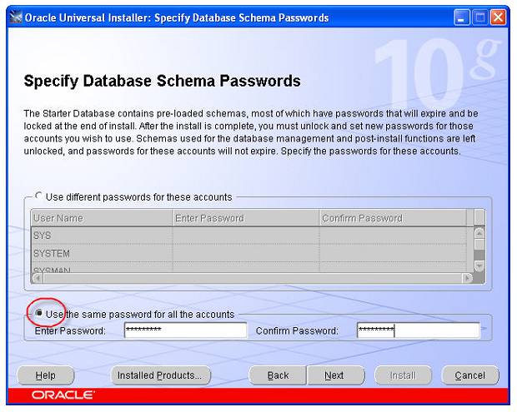

**1-28. The Summary window opens.**

**1-29. Click the Install button.**

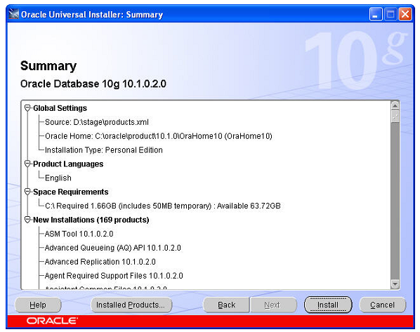

**1-30. The Install window opens. The time to install depends upon the speed and memory of your**

**computer and may take more than 45 minutes. Don’t be alarmed if the installer seems to be**

**stuck at a certain percentage during the installation. You can also ignore additional windows**

**that open during installation.**

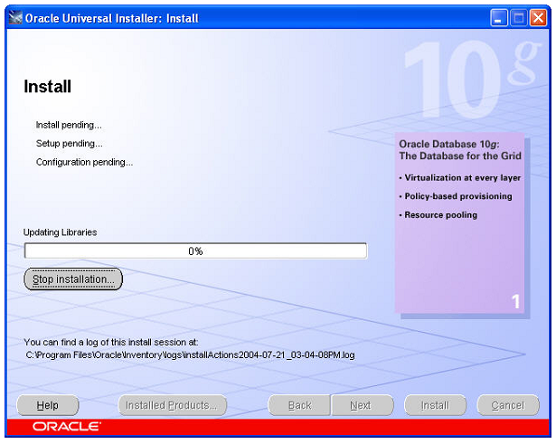

**During the Installation:**

**a. The Configuration Assistant window appears. No action is required.**

**b. The Database Configuration Assistant progress window appears. No action is**

**required.**

**1-31. The Database Configuration Assistant window opens.**

**1-32. Click the OK button.**

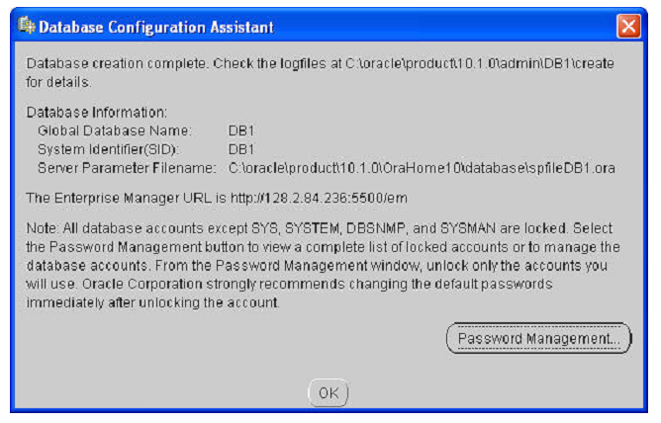

**1-33. The Configuration Assistant window reappears. Take no action.**

**1-34. The End of Installation window will appear.**

**1-35. Click the Exit button.**

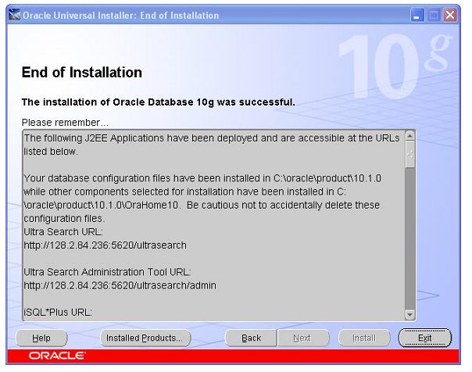

**1-36. The Exit window will display.**

**1-37. Click the Yes button.**

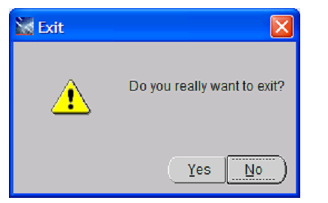

**1-38. After a minute or two, Internet Explorer will open and the Oracle Enterprise Manager**

**Database Control site opens. Login to the control using the following credentials:**

**a. User Name: sys**

**b. Password johnheinz (or the password you choose to use in step 1-27)**

**c. Connect As: change to SYSDBA**

**NOTE: If the Oracle Enterprise Manager Database Control site does not open automatically,**

**open Internet Explorer and go to http://localhost:5500/em**

**1-39. Click the Login button.**

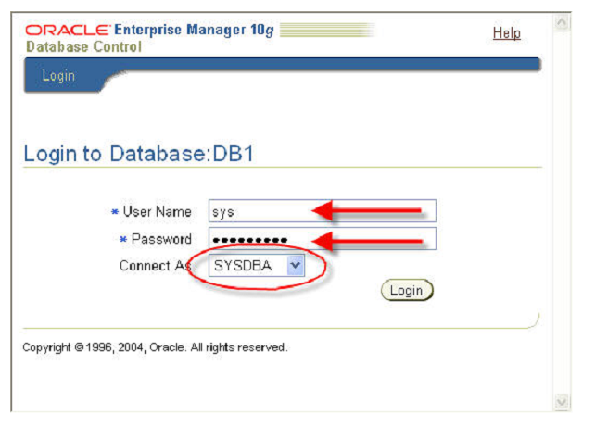

**1-40. The Oracle Database Licensing Information 10g web page appears.**

**1-41. Click the I Agree button located at the bottom of the page.**

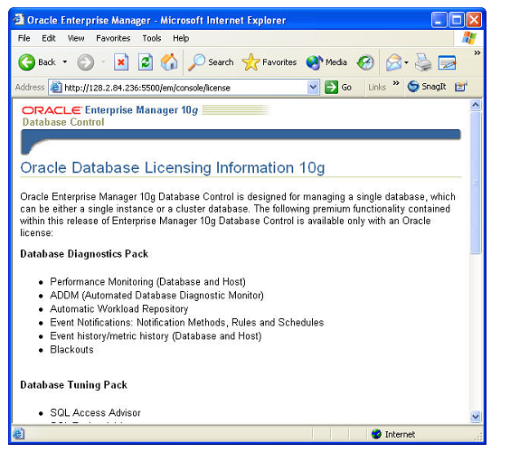

**1-42. The Database Control web page appears. You can view the many of the database management**

**metrics like status, uptime and availability. You can also perform many administrative**

**functions like user management and maintenance.**

**1-43. Click the Administration link.**

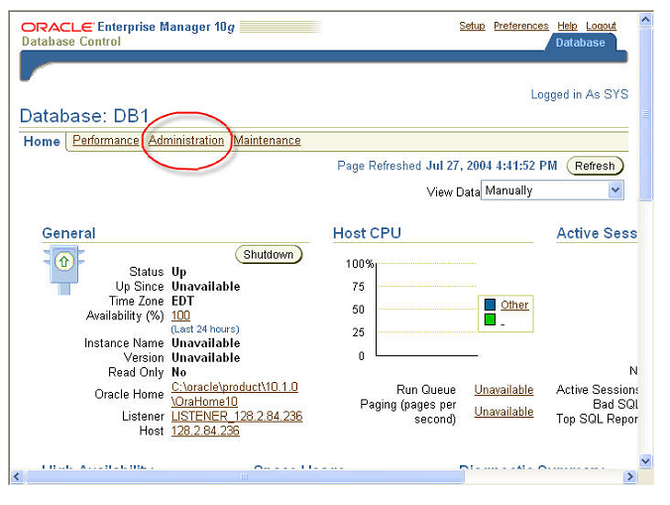

**1-44. Under the Security section, click the Users link.**

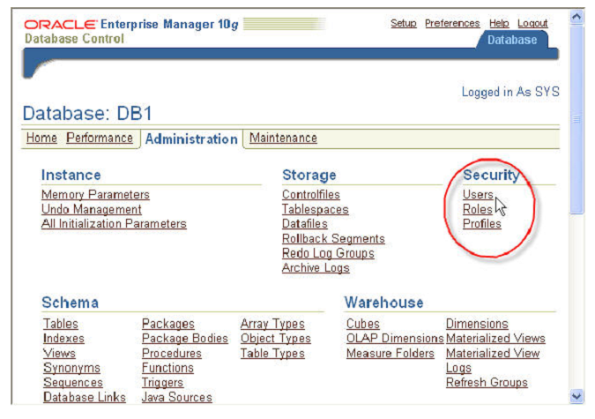

**1-45. The Users web page appears.**

**1-46. In the UserName column, click Scott**

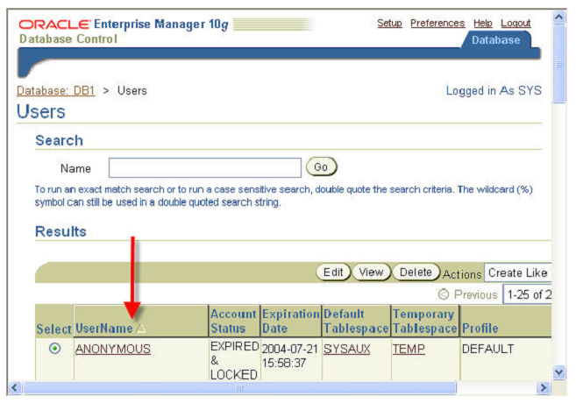

**1-47. The Scott User web page appears. By default, all user accounts are locked when Oracle is**

**installed. The Scott user account is used for testing and tutorial purposes.**

**1-48. In the Enter Password and Confirm Password fields, type tiger**

**1-49. In the Status field, select Unlocked.**

**1-50. Click the Apply button.**

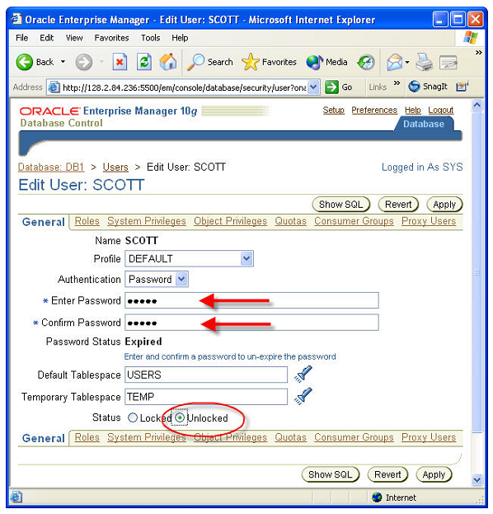

**1-51. The Scott User web page will refresh and an update message will appear at the top of the page.**

**1-52. Close Internet Explorer.**

**NOTE: Due to our configuration, the web based Enterprise Manager that you just used will not**

**function once the Oracle 10g installation is complete.**

**Step #2: Confirm the test database is functioning properly**

**2-1. Start Oracle SQL Plus:**

**a. Click Start**

**b. Select All Programs.**

**c. Select Oracle – OraHome10**

**d. Select Application Development**

**e. Select SQL Plus**

**2-2. The Log On window opens.**

**2-3. Login as:**

**a. User Name: scott**

**b. Password: tiger**

**c. Host string is blank.**

**2-4. Click the OK button.**

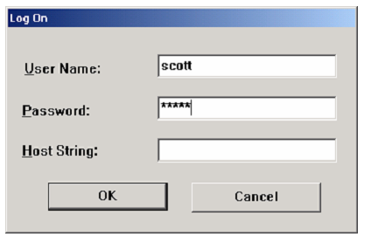

**2-5. The Oracle SQL Plus window opens.**

**2-6. At the SQL> prompt type:**

**a. Select * from dept;**

**b. (Note: don’t forget the semicolon at the end of the line)**

**2-7. Press the Enter key.**

**2-8. If the database is working correctly, your window will display the following lines:**

**DEPTNO DNAME LOC**

**----------------------------------------------------------------------**

**10 ACCOUNTING NEW YORK**

**20 RESEARCH DALLAS**

**30 SALES CHICAGO**

**40 OPERATIONS BOSTON**

**2-9. Type Exit at the SQL> prompt and press Enter**

**4)Creating Database Tables**

**1.Access ORACLE isqlplus home page using** <url:http://database> **ip address:port/isqlplus**

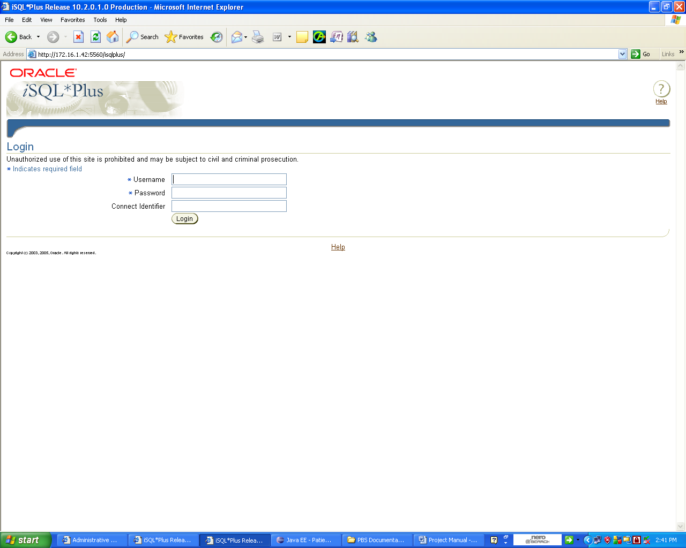

**2.Login Using Username and password**

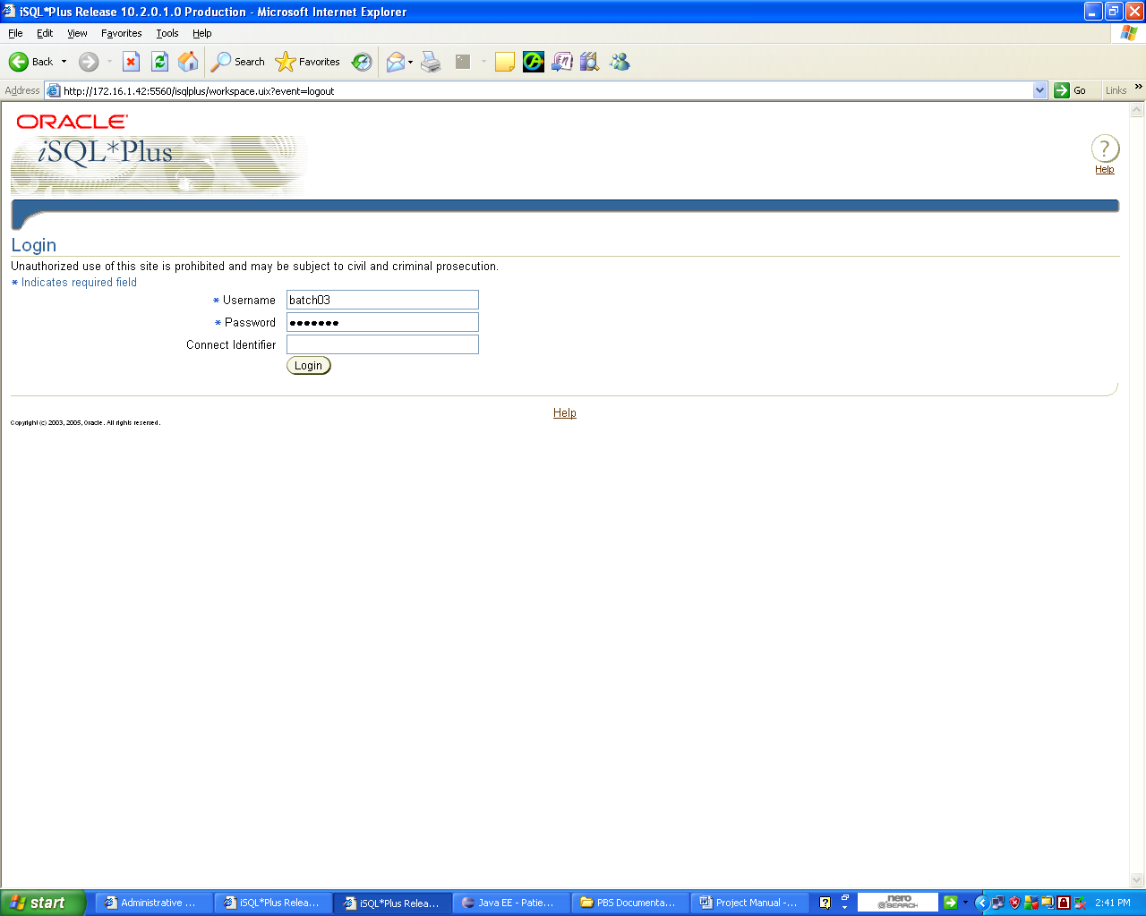

**3.Workplace will be displayed**

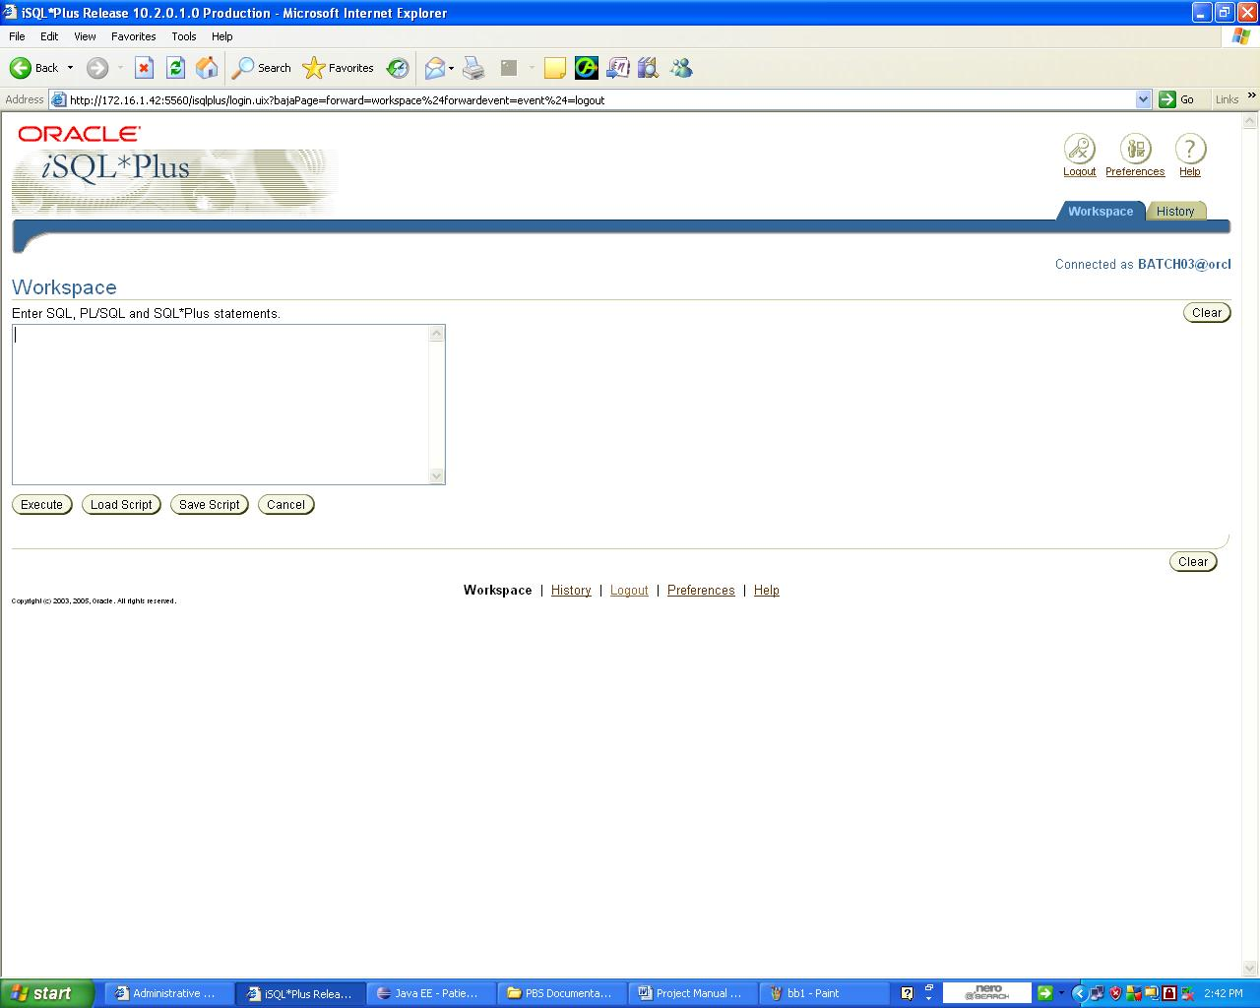

**4.Paste the DDL from the Database tables in the Deliverables folder a**

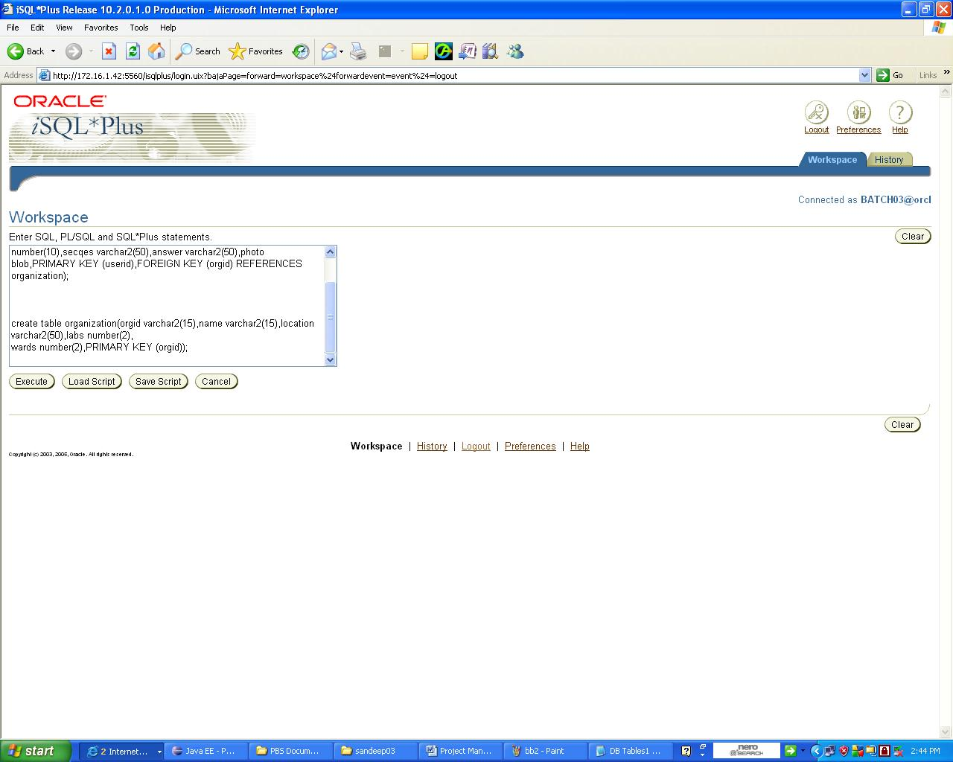

**5.Execute the DML commands to insert data**

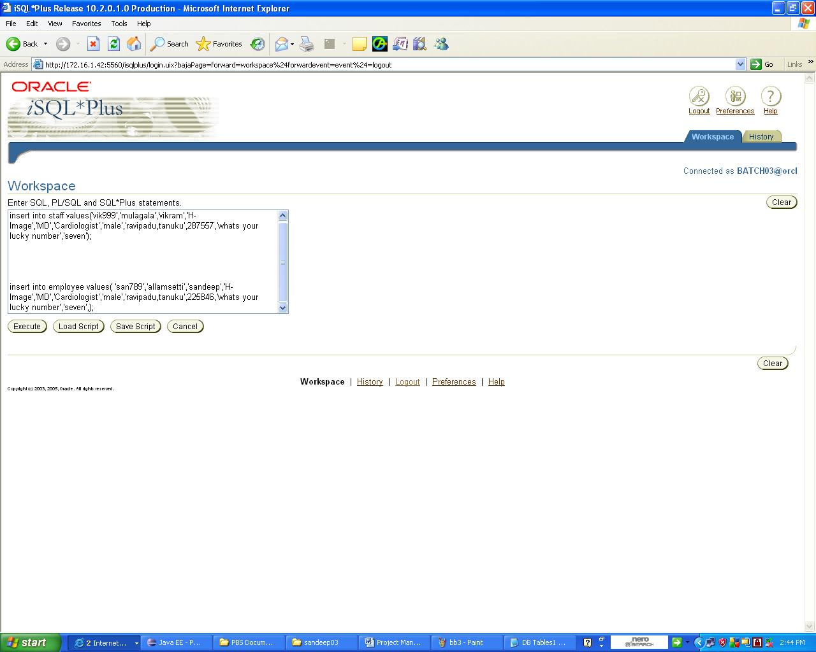

**6.Viewing all the tables created in the workspace**

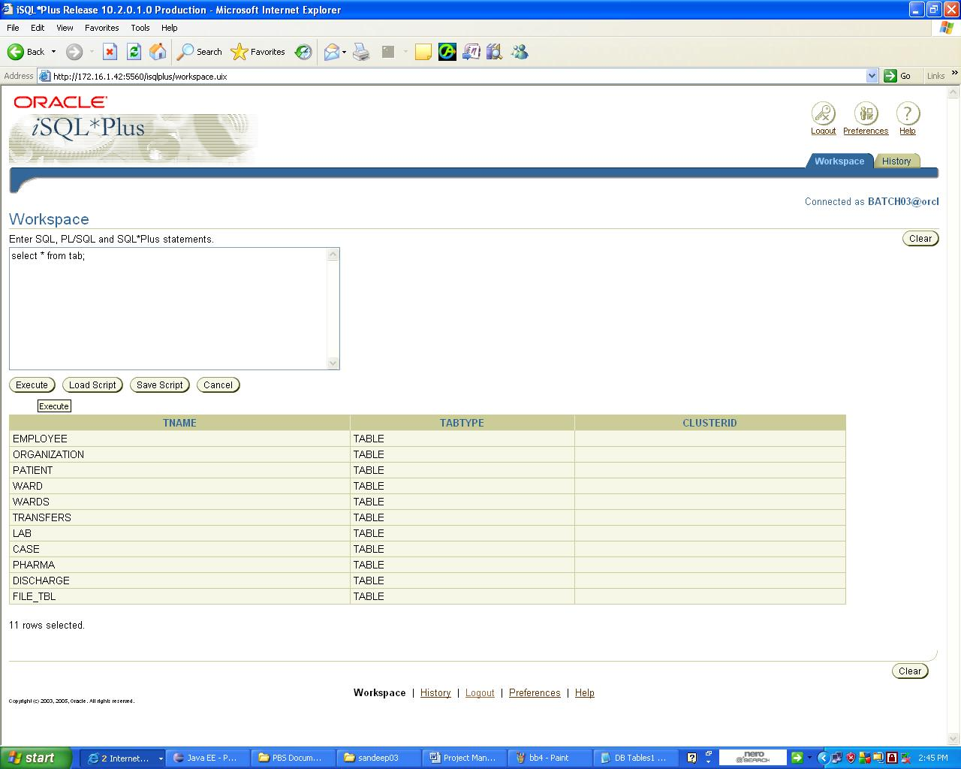

**7.Steps describing Project Functional Walkthrough after deployment**

**Home Page:**



**Home page of the System**

**Description:** The home page provides the necessary information that is accessed by the user and provides login form and registration for registration. The information in the home is open to all the users of the system.

**Registration page :**

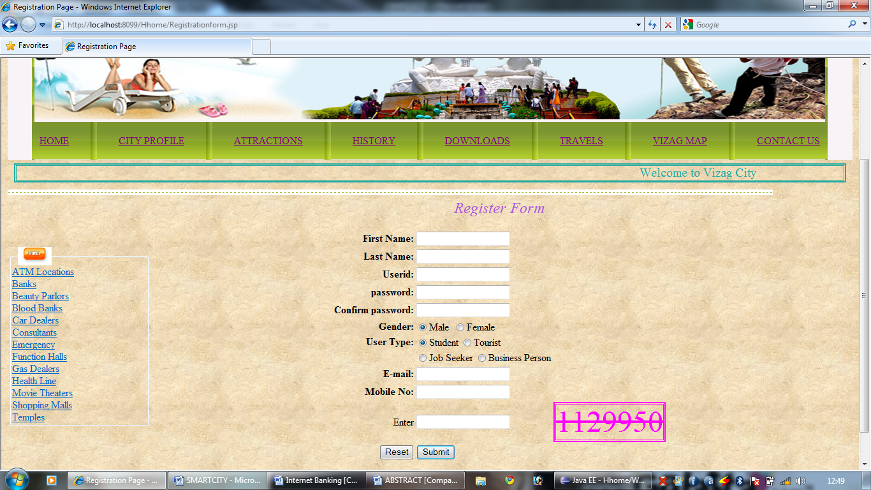

**Registration page**

**Description:** The registration page helps the user to register in order to posses the various services offered by the site .The various users of the system are tourist, businessman, student, jobseeker and administrator.

**Student Home Page :**

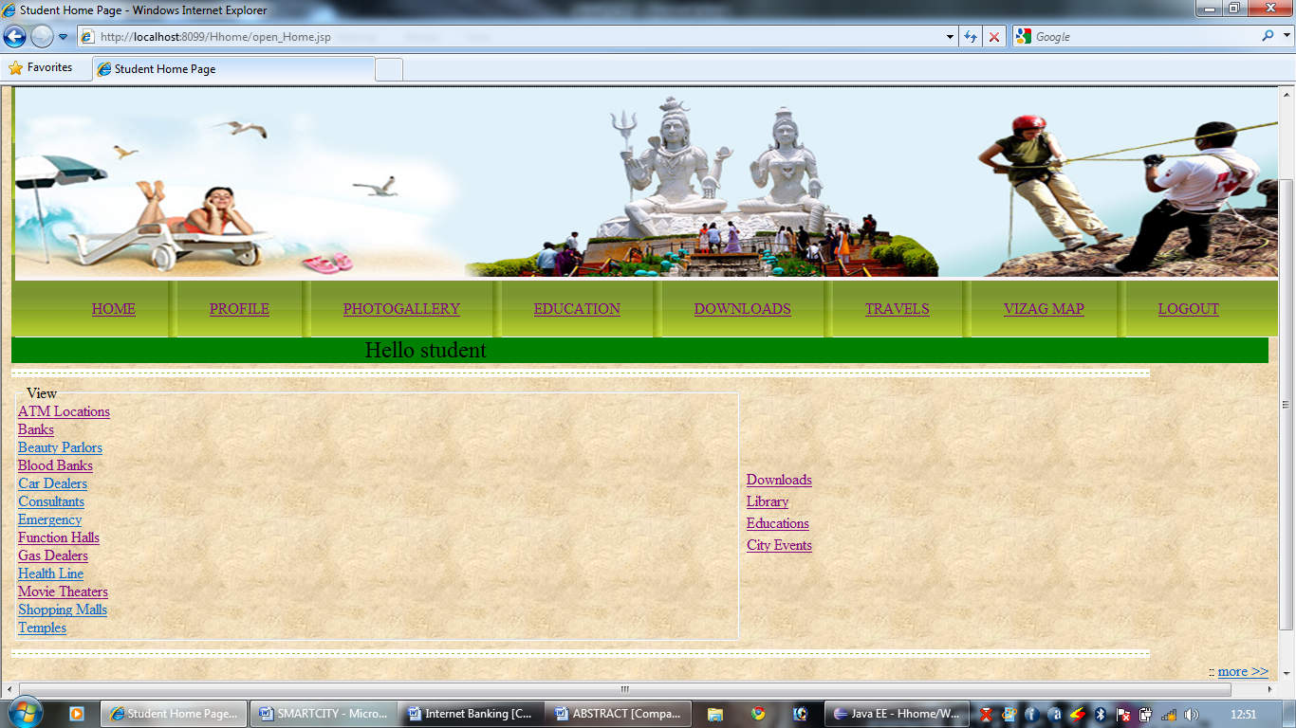

**Fig 6.4(c) Student Home page**

**Description:** The User who is registered as a student and login with his id and password will be provides with various downloaded services and can access other city inforantion . Every user will be provided with various services and maintain communication with other users.

**Industries :**

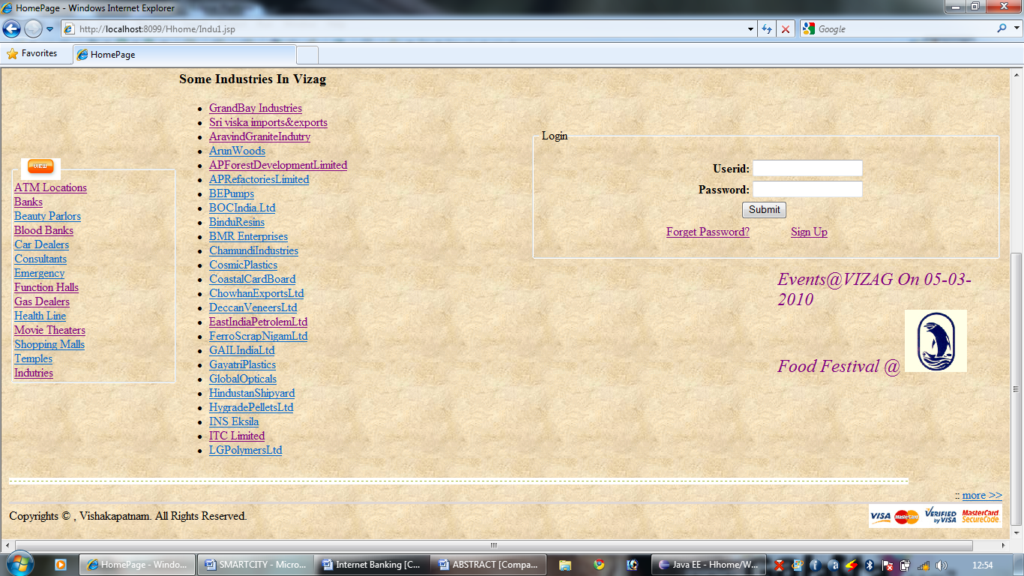

**Industries list of the city**

**Description:** The page provides the information about the various industries available in the city and their current operational status. The current updates of the industries in the city can be viewed .The administrator will make updates of the various information about the industries in the city. The current operational status of the industries will be available in the site.

**Display Industries Information:**

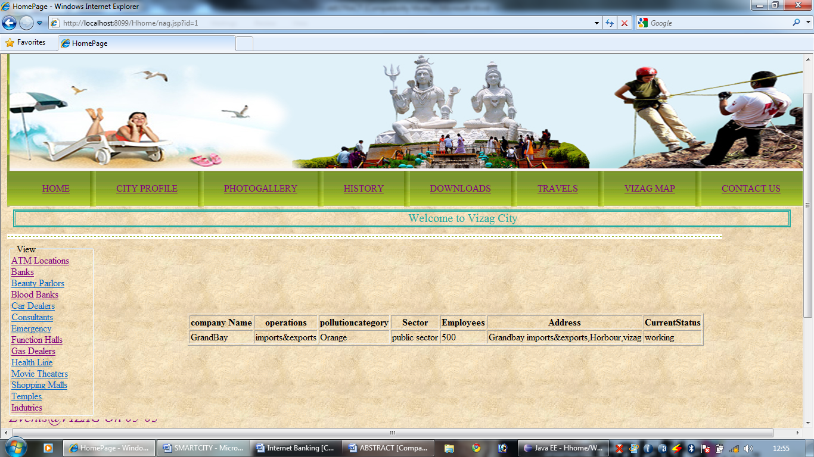

**Display Industries**

**Description:** The page provides the information about the various industries available in the city and their current operational status. The current updates of the industries in the city can be viewed .The administrator will make updates of the various information about the industries in the city. The current operational status of the industries will be available in the site.

**City History:**

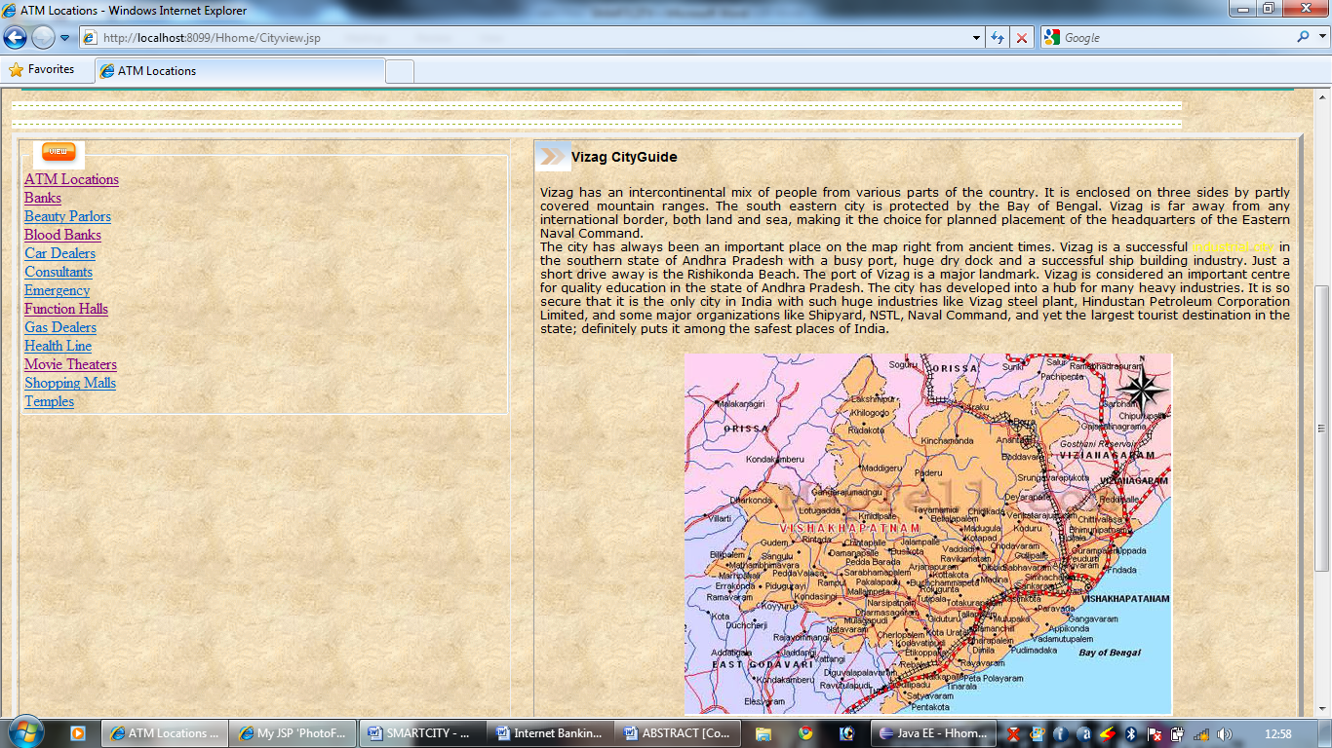

ATM LOCATION IN THE CITY

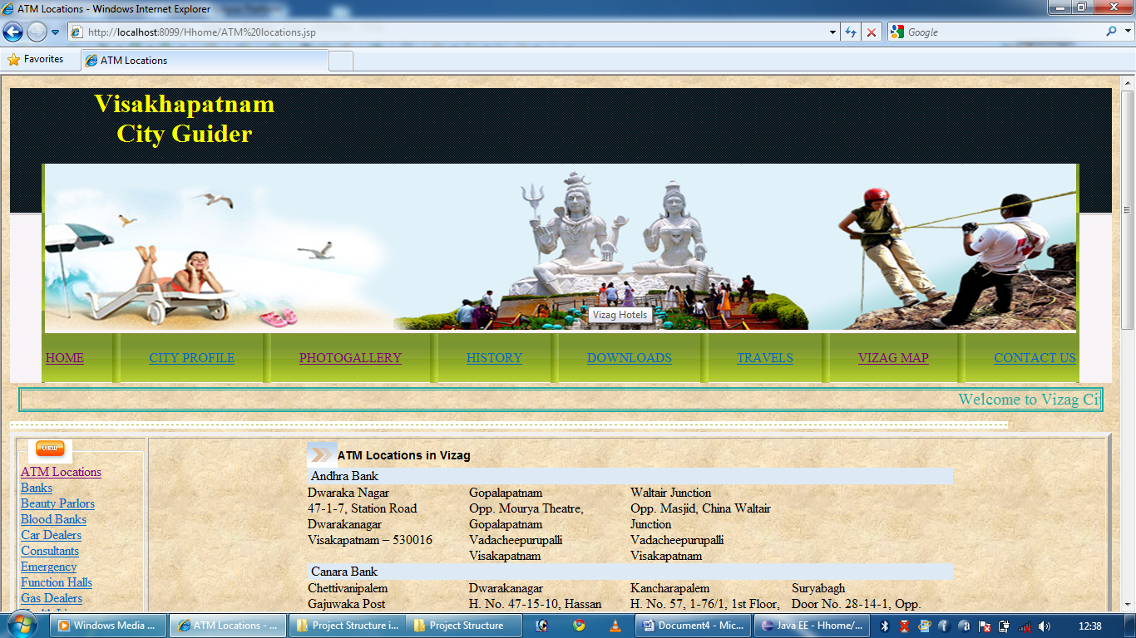

Description :Give information in the city

BANK Location In The City

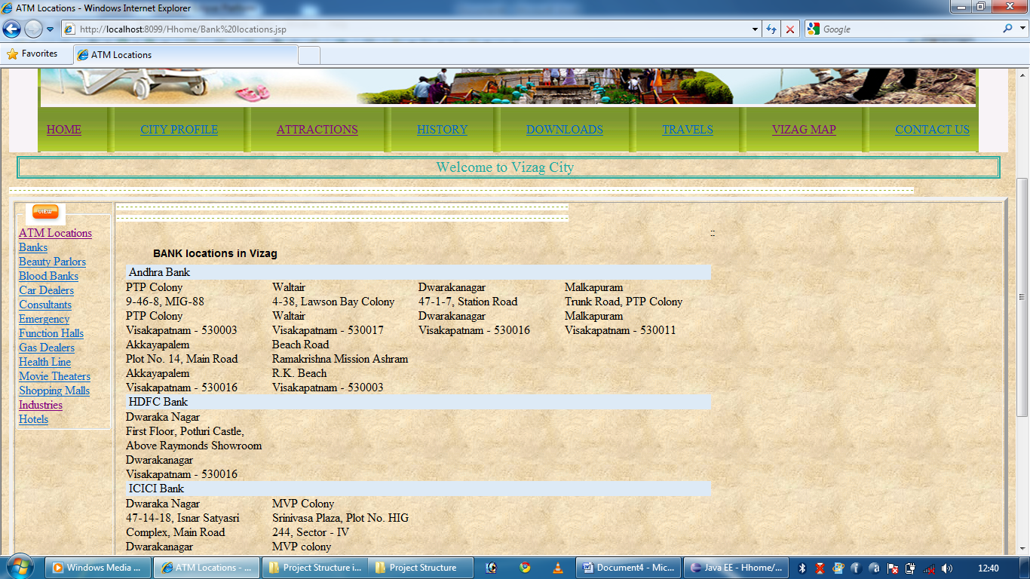

Description:Gives description about banks in the city

TravelSearch For Flights:

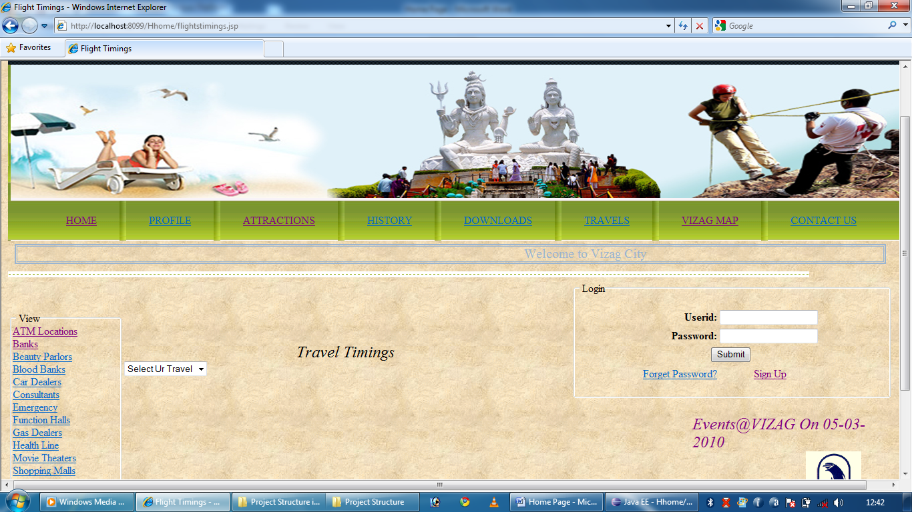

Select The type Of Travel

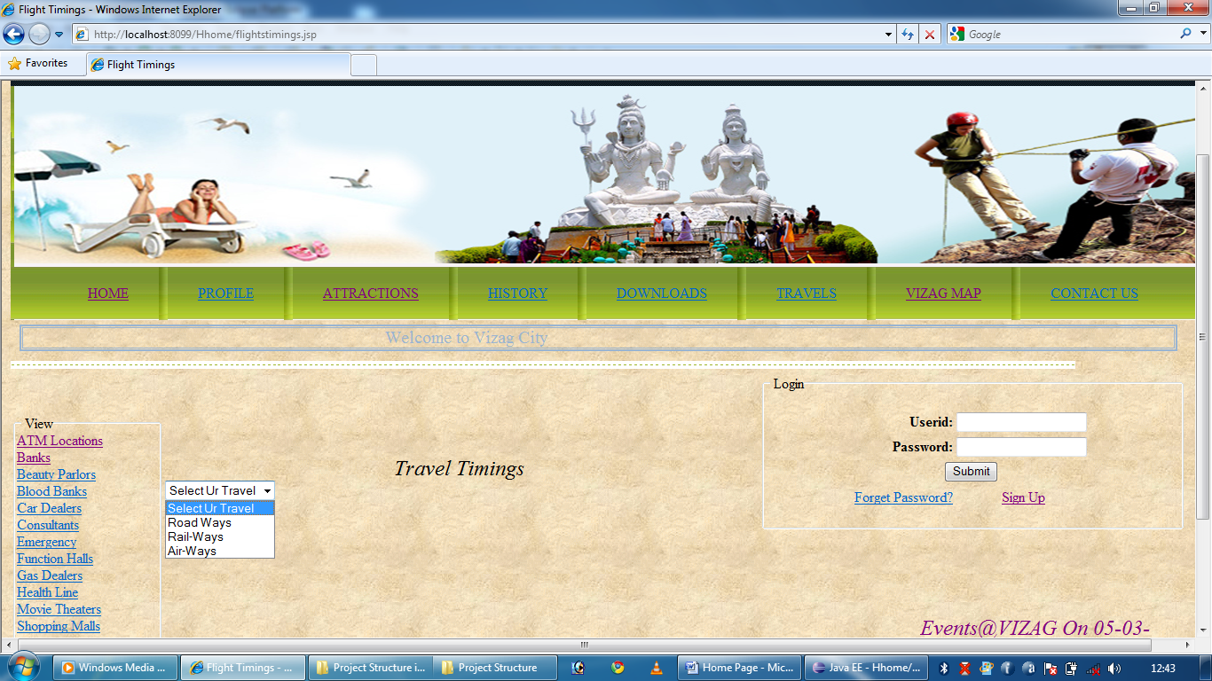

Selected Air Ways

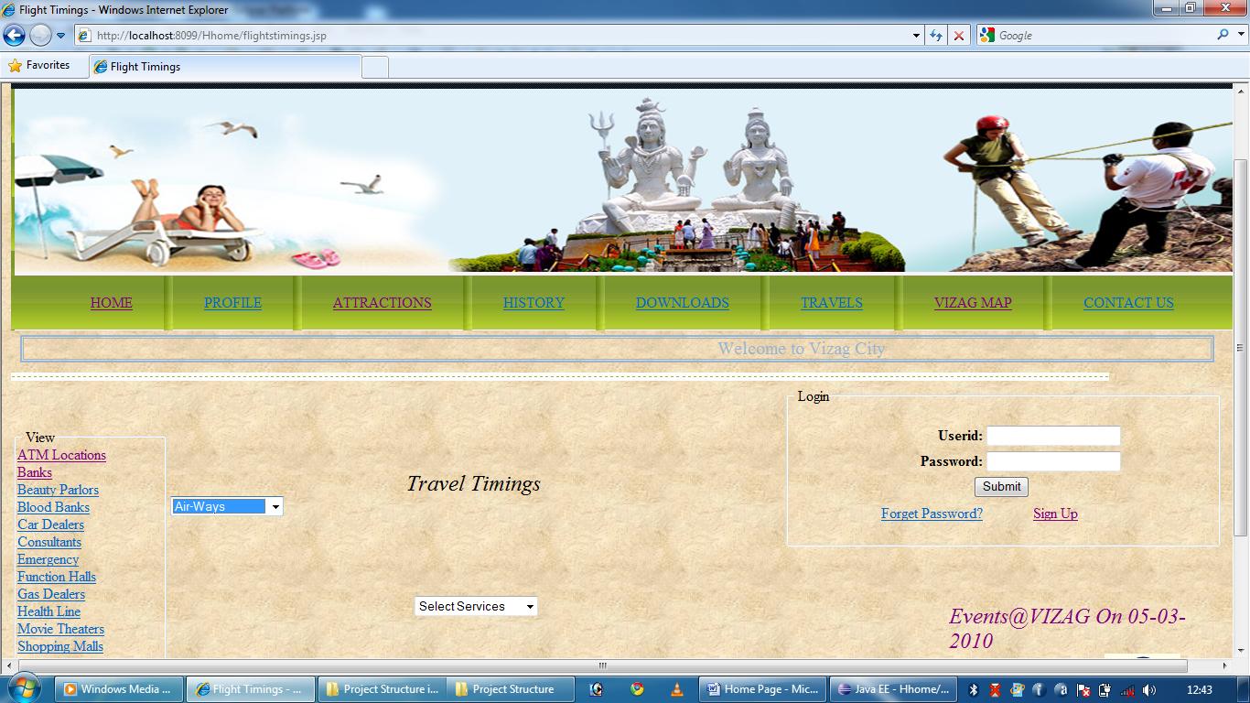

Select Type of Service

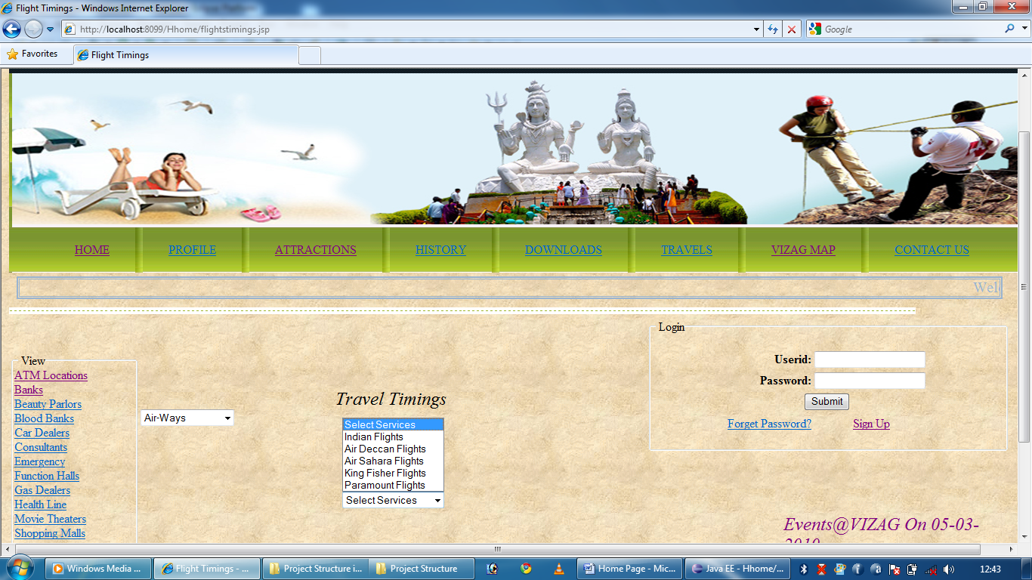

Select Type Of Service

